Book
2

civil engineering
BOOK 2

earth works
February 2013

INDEX
2.1 Introduktion to Earth Works 3
2.1.1 General 3
2.1.2 Definitions 3
2.1.3 Earth work 7
2.2 Quantity Estimation 9
2.2.1 General 9
2.2.2 Prism Method 9
2.2.3 Ramp Formula 10
2.2.4 Grid method 11
2.2.5 Simpson’s formula 11
2.2.6 Cross-sectional Areas 12
2.3 Soil types 13
2.3.1 General 13
2.3.2 Minerals 15
2.3.3 Classification of soil 18
2.5 Earthmoving 23
2.5.1 General 23
2.5.2 Mass Curve 23
2.5.3 Mass disposition 26
2.5.4 Transport logistics 27
2.5.5 Transport cost 28
2.6 Production 29
2.6.1 General 29
2.6.2 Production Formulas 29
2.6.3 Efficiency factors 31
2.7 Earth machinery 35
2.7.1 General 35
2.7.1 Dozer 35
2.7.3 Loaders 43
2.7.4 Excavator with towing shovel 48
2.7.5 Hydraulic excavators 53

2.1 Introduktion to Earth Works
2.1.1 General  2.1.2 Definitions  2.1.3 Earth work | Industrialized building – or production and assembly of prefabricated  Earthwork includes solution, loading, carriage and may also include compression and leveling. Material can vary from the softest clay for the toughest rock. Usually, the definition of rock material is material so compact that they have to be loosened by blasting.  Cost of equipment will normally play a more major role in earthworks than other works. This is because the earthworks are generally stronger mechanized and that costs of materials are usually relatively minor. When planning the execution method, the factors of particular importance are:  - Type of soil.  - Scope of Works.  - Deadlines for the work.  - Climatic conditions.  - Transportation.  - Labor relations/intensively.  Modern soil material requires a very large investment. This is true in general, the larger soil volume, the longer it must be moved and the shorter the time available, the larger and more expensive machines must be used. Is the soil volume below a certain threshold, it means the cost of shipping and installation of equipment is usually so high that there are reasons to investigate whether less heavily mechanized working methods would be more advantageous. It is very rare that one can immediately determine how the excavation work should be performed. It will usually be necessary to explore more options. E.g. execution with the use of scrapers vs. excavators and trucks within each option to find advantageous size and number of units.  Tip or dumps are terms used to designate the place where you can get rid of the soil. For example a port area, a landfill or an abandoned gravel pit or other fills area. Pure dirt can usually be delivered free of charge, while other surplus material such as broken up road surfaces only will be received at an agreed price.  Land Disposition is used in the planning of dirt works, which indicates the amounts of soil to be moved anywhere, e.g. whether soil after excavation is transported directly to future incorporation, or whether through a depot first and the location of this depot. About the amounts of soil to be moved directly to the tip, and whether to retrieve re-fill materials externally. It is obviously most economically advantageous to seek balance in the affected construction site so that there are no need neither to move soil away or to the site.  Material Planning identifies the equipment used in the various sub-tasks as equipment type would be strictly linked to such distances.  Preparatory work consists of clearing the site for trees, shrubs, etc. and removing of topsoil for later relaying on finished slopes, banks, adjusted terrain, in planting holes and the like.  On grassy areas in excavations or filling areas where the topsoil must be removed, the grass roots first must be removed in a thickness of 50-100 mm, since this material is not suitable for coating the slopes or banks.  When calculating topsoil depots one must be expected to depot 20-40% more than corresponds to the geometrical volumes of the later designated topsoil, since there always is a loss of topsoil lost when laid out. Soil should be loose laid up in not too high piles to prevent self-compression and hence to lose some of its cultivation value.  Since topsoil or mold must not be built in afterwards, all soil in excavation areas must be stripped. Mold in filling areas must be stripped if instance is less than 1 m below the finished road surface, and if it occurs in greater thicknesses than the equivalent of ordinary arable top soil thickness (250-300 mm). Stored mold shall be kept free of weeds.  Weather-related measures are first and foremost about keeping track of large volumes of water that can occur on site and make it rough. All excavation must be carried out against rising terrain for the sake of digging in the dry or lightly dewater area and stripped areas must always be kept dry and clean, thus removing loose soil. One should not leave an excavation or filling space, unless they have been leveling and efficient compression and drainage of closed areas or holes. And when work resumes one should have checked weather conditions in relation to the sensitivity of the soil to be addressed during the day.  When planning the project and its execution, both the designer engineer as well as the executing contractor ensures that all transport can happen on dewatered transportation routes.  During winter one have to concentrate work in smaller stages, and the soil can be covered with mats that prevent the frost from going into the soil, but also using natural geothermal heat to thaw frozen earth’s crust.  Soils can be frost sensitive, which manifests itself in the soil expansion when soil-temperature drops below 0°C. It shows as risings that can damage overlying structures and eventually cause softening and subsidence, when the frost goes out of the ground. Whether a soil is frost sensitive can be determined from figure 2.01. Here are the dotted lines boundary curves. The material sheet to the right is not in itself frost sensitive, but it is so coarse that there is a risk that the fine frost hazardous material can penetrate. At the opposite side it must be said that soil with more than 50% clay is no frost sensitive.  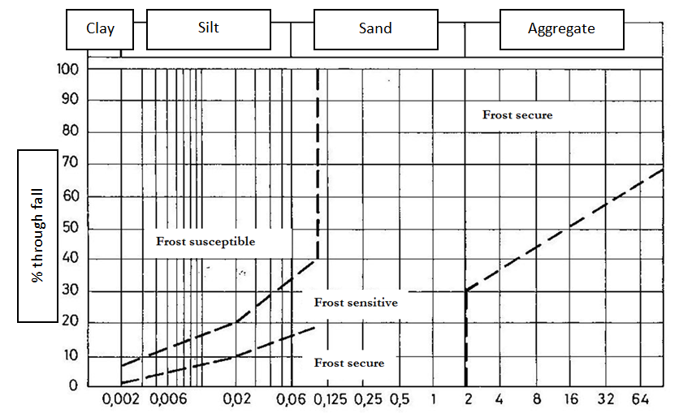  Figure 2.01 Schaibels boundary curve for soils frost susceptibility  Otherwise, not to be frost sensitive a material must have a grading curve, which is determined partly by sieving and by sedimentation, which runs entirely in the frost-proof area. When using moisture-sensitive and frost sensitive soil types, there must be conducted either covering with other dense coating like paving or covering with frost-proof fills, which correspond to the maximum frost depth and effective drainage. Track bed used on the soil surface after clearing and on the soil surface to serve as a foundation for a superstructure. Here, no more than 10% of the track bed must deviate more than 0.04 m from the projected elevations. The term sub-graded soil is used on the soil under the plow layer and also on an average type of soil consisting of a mixture of clay and sand. Subgrade works consists of excavation, transport and eventual incorporation of sustainable material.  Building-in able soil is building-in suitable if it can be placed in a filling and machined to such a consistency that it achieves a given, required bearing capacity. These requirements can usually be met if the soil solids is composed of such minerals which usually occurs in clay, sand and stone and whose water content is suitably low and the soil is not frozen. Soil, whose water content is so large that the air content almost disappears when compressed can be difficult to install. If the soil is saturated in greater or smaller batches, the recess suitable soil will pressure distribute through the water instead of through the soil grains and thus push them apart so the soil resistance disappears. Such soil may be building-in suitable by drying and lime stabilization when the other conditions for building-in are present.  Soil may have higher water content in natural posture than is acceptable for a required compression. One must be aware that the soil will always be considerably more watery in Denmark until mid-May, since plants at this time will use more water than is supplied by precipitation. This means that from May until the plants water consumption is less than precipitation, it will generally be trouble-free to incorporate moisture-sensitive soils, clay, silt and fine sand. Possibilities for drying are greatest when the air is dry and warm windy weather and surfaces machined up so that evaporation can occur from a large surface. If there are enough building-in suitable soil within the construction area, the choice of the most viable alternative based on an economic assessment of the costs of these drying steps vs. hauling building-in suitable soil from outside in and driving away the unsuitable wet soil. The topic: incorporation of soil is described in detail in Section 2.3.7.  Soft-ground Works consists of replacing unsustainable materials with sustainable material or removal of non-sustainable material. None building-in suitable deposits are materials containing organic materials such as topsoil, peat and organic silt. Deposits may also involve trash from previous dumps. As mentioned, frozen soil and soil with such a high water content that it cannot be compressed, or soil which cannot be stabilizing, even building-in suitable because such soils cannot be compress. Well graded gravel species are easy to integrate to a building with good quality. Well graded gravel species are easy to integrate into a construction with good quality. But as these soils exist only in limited quantities at acceptable prices, it is necessary to use the less good soil in such a process that any less good quality material still can achieved acceptable soil structures. Where the soft bottom does not occur in large thicknesses, where the material is compression able, the soft bottom may be lying.  The compression energy, which in any case must be used, then penetrates the entire layer. This can be achieved by the use of a falling weight, a weight consisting of a large heavy block mounted on an excavator. The falling weight brought repeatedly to fall from great height, until the layer has reached a dry bulk density, corresponding to the normal requirements for building-in suitable soil. If the soft-bed cannot be treated this way, it may be necessary to remove it. In most cases it will be necessary to remove it completely from the site, but there may be cases where it is possible to apply it to the design of the surrounding terrain. It may be especially suitable in areas where the bottom is soft, and therefore it may be necessary to use materials with relatively low volume as filling material.  Depending on the type of soil, water content and groundwater table, the excavated construction pit will be dry or filled with water or with some water on the bottom. Are there smaller puddles left on the bottom of the pit that it is not worthwhile to remove lay out as thick a layer of friction fills, so it is possible to proceed with incorporation of soil on a dry surface after it is compressed. The gravel fill’s height above the water table should not be less than 300 mm.  Grubbing usually occurs at a depth of 600-800 mm, to loosen soil sufficiently so plants can thrive in it. Articulated Control Areas, which has been necessary to process with machinery, may have been driven so hard that a grubbing is necessary. This can be done by tearing the ground up with knives, mounted vertically on tractors.  Final works usually consists of the laying of topsoil in preparation for planting or grass seeding. Slopes and verges sown for technical reasons with grass to create a root system that can help maintain stability. Previously, grass was sown directly on soil, but now it has become more common to spray the grass seeds onto the surfaces.  To that purpose a motor syringe mounted on a truck with a tank from which a mixture of grass seeds, fertilizers and emulsion is pumped. Such a mixture can also be sprayed onto the surface without topsoil with good result. Consumption for seeding is 1-1.5 kg each. 100 m².  Side borrow and side spoil disposal (side dump) The issue of using side borrows and side spoil disposals (side dumps) occur by road works and can be relevant in two cases. The first case deals with roads where there is either soil surplus, which requires side spoil disposal (side dump), or soil shortage, which imposes side borrow. The second case deals with roads where there may be very long soil transports. Here must it be considered to replace such a long transport with side spoil disposal (side dump) off the excavated area and side borrow off the in-fill area.  Length haul and side haul Length haul (moving soil along the road) and side haul (moving soil side ward across the road) of soil is also an expression originated from road construction. By the use of stationing one length divides a road in sections. Should soil be moved from one section to another, one talks about length haul while soil dredged and filled within the same section is called side haul.  Forced Transport is when a portion of the total soil work in some cases is predetermined and cannot freely enter into an optimization view about soil moving works. Filling coefficient used on the relationship between the soils in built condition, and what it fills in a natural condition. The size of this coefficient depends among other the compression level and possibly subsidence of underlay. For Danish conditions, one must average enough to count on a filling factor of 1.1 to 1.2, i.e. be excavated 10-20% more than mathematically calculated to be refilled. Before placement of the new soil one should compress the filling area in 0.2 m depth.  Earth work includes operations where the soil is dredged and loaded onto transport vehicles and then being moved and built as built-in or filling soil. If there is a surplus of soil or it is unsuitable for use as built-in soil, it will be discarded and unloaded on a tip. Topsoil to be used for coating the slopes, etc., place in stockpiles and relayed when earth works is nearing completion. Both excavations as built-in shall be designed and executed in a manner that there is consistently created an efficient drainage of both precipitation and groundwater. Soil surfaces must be kept so regulated and compressed, that surface water runoff and soil is not soaked in the event of rain. When operating with machinery and transport vehicle, traffic must be distributed evenly over the surface so that there are no deep wheel tracks created. Filling Soil should be laid out in a layer of a thickness that allows that with the used selected compression equipment will achieve the required compaction throughout the layer thickness.  Unsuitable soils Not all excavated soil is suitable as filler, but may be removed and replaced with other soil, retrieved from a side borrow. The excavated soil can be suitable for incorporation, if its water content is far above what is optimal for compression. From the geotechnical surveys it is usually broadly known what excavated soil will be necessary to discard. Exactly how much soil to be replaced can only be determined during the work itself, because the quantities depend both on soil type its condition and the weather during excavation activities.  In soft-bed areas with dangerous subsidence is generally done an off-digging of soil down to solid ground. The soft sediments are exposed and replaced with sustainable materials.  Subsidence dangerous soils include in Denmark especially post-glacial sediments with organic content (humus, silt and waste) but also soft Late Glacial sediments of great thickness can give rise to unacceptable subsidences. The water content of post-glacial deposits can be up to 100% so that the primary creep can be very large. In addition organic soils may also lead to extreme subsidences as a result of secondary creep.  If you meet contaminated soil, such as old landfills or soil that contains petroleum or chemical residues, the municipal authorities must be informed. Contaminated soil will normally be required replaced and driven to a legal dump or to a cleaning facility. Rarely there will be given permission to leave the dirt untouched on site.  Top soil In Denmark, the top layer of soil as a rule of topsoil. Average thickness is around. 30 cm. When starting soil works, top soil is a placed in stockpiles and relayed later when soil works are completed.  Compaction The compacting of soil means the increase of soil density by extrusion of air. By compacting an effective improvement of soil strength and deformation is performed. Dams, backfilling e.g. is thus built always layer by layer and each layer is compacted thoroughly before the next layer is placed. Also in excavation areas is conducted a compression of the upper layer of the bottom because it is always possible to improve the soil natural density.

2.2 Quantity Estimation
2.2.1 General  2.2.2 Prism Method  2.2.3 Ramp Formula  2.2.4 Grid method  2.2.5 Simpson’s formula  2.2.6 Cross-sectional Areas | Mass estimation or soil calculation is an inventory of the soil quantities or volumes to be dredged, moved, disposed of or incorporated. An important part of the basis for considering a building project, earthworks included, is the quantities involved in the various components that you can divide a construction works in.  The quantities used in the project design e.g. to obtain balance between excavated and filled volumes. The quantities are the base for procurement between client and contractor, and are used during construction to regulate the bid prices if the actual quantities of work in progress turn out to be different than those that were presupposed in the tender.  Quantities used in planning for pricing, includes machinery calculations in which the equipment size and performance to cope with the quantities during a given time period. Quantities also use as control, where you make sure that resources are in place at the right time and while working; controlling that quantity balance is according to plans and schedules.  Final quantities are included in the final account basis between the contractor and blue collar workers. In addition they are used by interim applications for payment from the client to the contractor. In this section are shown some of the mathematical methods available for calculating soil quantities.  After prism method soil calculation are made by dividing the land to be moved in prisms, while giving a series of cuts perpendicular to the longitudinal axis. The cuts are made so close that changes in soils cross section can be considered linear from cut to cut. In the subsequent Figure 2.02 is shown principle in prism method for a road in a refilling area. A series of cross sections are placed whereupon cross-sectional areas of these are determined.  New road in terrain  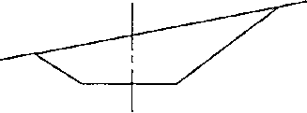  Cross section of excavation area, cross section in the filling area  Figure 2.02: Prism Method.  Defines a series of equivalent sections with spacing a as the figure shows, the total volume (quantity) is according to Formula 2.01:  V = (½*F₁ +F₂ +F₃ … +F_{n-1} +½*F_{n}) * a  Formula 2.01  Soil between two cuts (filling or excavation) can be regarded as a prism whose volume can be calculated by Formula 2.02:  V = ¹/₆ * (F₁ + 4A +F₂) * a  Formula 2.02  Where:  F₁ = area of the one end-surface  F₂ = area of the other end-surface  A = area of the center cut  a = length of prism  If F1 and F2 are roughly equal in size, then the median of cut surface area almost is equal to the average of the two end surface areas. The volume then is:  V = 1/2 (F1 + F2) * a  Formula 2.03  The cuts must be so close that the intervening soil volumes may be regarded as prisms. Therefore cut in the stations should be where the shift work does not vary evenly, e.g. bends in the terrain length profile and changes in the roads cross-section. The cuts are placed in a constant, appropriate space depending on the actual conditions. In Denmark, normally an average distance of 20 m or 40 m, possibly 100 m.  The Prism method gives space for a calculation error on stretches where the road lies in a horizontal curve. The reason is that in curved stretches two cross sections perpendicular to the longitudinal axis not are parallel to each other. If the terrain is located in roughly the same level on both sides of the road the fault is of no relevance at smaller radii, but should be evaluated closely by curves with radii less than approx. 100 m.  To indicate slope steepness is using the terms construction, slope and rise, whereas in practice is not always clarity about the concept of slope. The slope is tangent to the angle with horizontal level of the bank, often shown as 1:2 (2 horizontal and 1 vertical). The increase in the slope is in %. The slope is set with just a single number that denotes cotangent of slope angle.  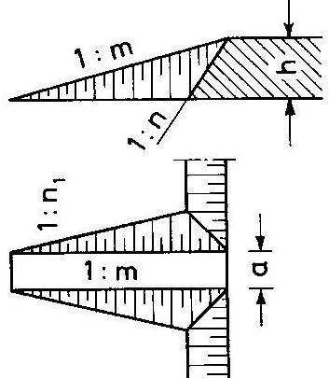  Figure 2.03: Ramp by open excavation.  With the given terms of slope, one can be from Figures 2.03 deduce ramp formula.  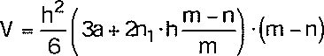  Formula 2.04  This formula can be applied to determine soil volumes in the ascending and descending ramps in, among others, construction pits. When execute ramps in connection with sheet pile wall excavations will the specified slope lengthwise the excavations bank be vertical and the formula is reduced hereby to the following:  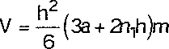  Formula 2.05  Shall a larger area in a construction project be reprofiled applied from surface leveling known Square Grid Method. In Figure 2.04 is shown the curves for old and new terrain and an inlaid square grid with side a. In the corner points is read the height difference between the original terrain and the new. One can e.g. for filling soil count h negative and excavated soil h positive. Soil volume within each grid can then be set into  Formula 2.06  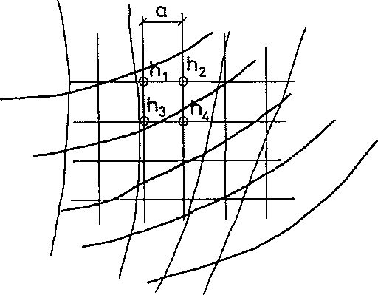  New terrain  Original terrain  Figure 2.04: Square grid method.  The most accurate calculation of amounts of soil is obtained by using Simpson’s formula:  V = ¹/₃ * a (F₀ + 4F₁ + 2F₂ + 4F₃ + 2F₄ + …. + 4F_{2m-1} + F_{2m})  Formula 2.07  Where F which usually stands for cross sections spaced by equivalent distances, and m as an integer indicating that there must be an even number of intervals.  For m = 1 you get Simpson’s formula in its simplest version:  V = ª/₃ (F₀ ₊ 4F₁₊F₂)  Formula 2.08  Since the formula has a residual of accuracy that is proportional to the fourth derivative differential coefficient, the exact curve with variation between cuts up to third degree. Applied to a prism, a body with two parallel ends of such a construction pit, you get back to formula 2.02a:  V = ^{h}/₆ (G + g + 4A)  Formula 2.02a  Where h is the height of the pit, g the floor area and G upper involved area and A is the area Vz height up in the pit.  To use the prism method of soil calculation it is necessary first to determine the size of each section area. This is done for each section by determining excavation area A and filling area P separately.  A distinction between final soil calculation, where for a detail project it is about evaluating the work moving size, and a preliminary calculation, where one in connection with a draft design is just interested in the approximate size of the moving work.  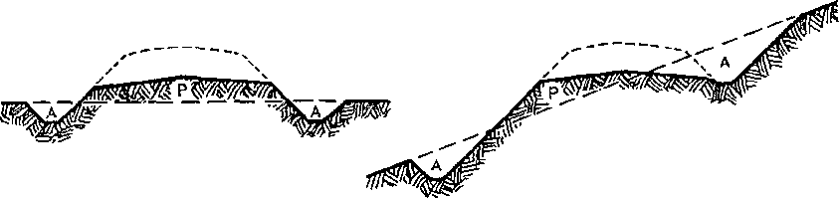  Figure 2.05: Cross section of excavation as well as filling  By a preliminary soil calculation a number of simplifications of cross profile are often used, both for road as for the terrain. One just needs to include:  - Terrain Line assumed horizontal  - Cross-section is assumed constant

2.3 Soil types
2.3.1 General  2.3.2 Minerals  2.3.3 Classification of soil | The heading Soils are used here as a generic term for all natural-made deposits and formations from terrain and downwards. These materials are also known in geological terminology for earths and divided into sedimentary rock (e.g.. clay, sand, limestone), metamorphic rocks (e.g. slate, marble, gneiss) and igneous rocks. The magmatic rocks are further broken down into volcanic rocks (solidified near the surface, e.g. basalt) and plutonic rocks (solidified in the Earth’s deeper layers, e.g. Granite). Metamorphic and igneous rocks are collectively called Basement Rocks.  In the following the term soils and soil-layer mainly are used about soft layer, while the terms rock and bedrock refers to hard layers.  Overall, the vast majority of soils in Denmark upper soil layers occurred as loose sediments, i.e. as particles transported by water, wind or ice and deposited as clay, silt, sand, gravel and stone. Only on Bornholm a part of the upper layers are bedrock, granite and gneiss. Danish sediments can after their formation modes divided into seven groups:  - Water-deposited sediments (e.g. gravel, sand and consistent clay)  - Wind deposits (e.g. fine sand)  - Material rendered from a glacier (e.g. clay)  - Accumulation of shells and skeletal remains of small animals (e.g. lime, stone, and diatomite)  - Accumulation of organic matter (e.g. peat and organic silt)  - Chemical precipitates from water in soil (e.g. withholding lime and bog iron ore)  - Chemical precipitates from seawater or salt island (e.g. rock salt)  Water-deposited sediments. The water-deposited sediments are formed by precipitated material such as meltwater, sea water or fresh water. Common to all water-deposited sediments is that they are graded and that their grain size is determined by the speed and turbulence that have been in the water on the deposition time. In strong flowing water, are only stones, gravel and sand deposited while in quiet and calm water only clay and silt are deposited.  Wind Deposits. Wind deposits typically consist of very well graded fine sand, called shifting sand. The grain size of the win deposits may also be in the silt fraction, and is then known as loess. Silt fraction is grain sizes between clay and sand (see Figure 2.06).  Glacier Debris. A glacier is a progressive mass of ice. Normally, the glacier obtains material from the underlay when it slides forward. In contrast to the material being transported by water and wind, there will not be a sorting of the material being transported by the glacier.  A clear indication of that type of soil is created by the melting of a glacier is that the soil type is unsorted, i.e. in the same soil-sample typically finds clay, sand and stone. Glacial deposits called moraine, and depending on the main soil component distinguishes between till, moraine silt, moraine sand and crushed gravel. For these groups till is by far the most prevalent in Denmark  Accumulations of shell material. The biological life in marine and lake water produce shells and skeletons composed of either lime (CaC03) or silica (Si02). Layers of silica shells also called diatomite after a group of silica algae, called diatoms.  Depending on how much material entering from the dry land sediments will on the seabed or lake bed be more or less dominated by lime or silica. Examples are the thick deposits of chalk in the Danish underground, the presence of diatomite by Mors and Fur in the Limfjord region. The latter diatomite is also called Moler soil. Accumulations of shell materials in freshwater environments (lakes) may be in the form of diatomaceous earth (diatomite) or in the form of lime silt (dominated by the material of lime).  Accumulation of organic matter. All plants and animals contain molecules with carbon atoms, often described as organic matter. When dead plants and animals rot, the organic material transforms with oxygen into carbon dioxide and water and inorganic salts.  If there is no oxygen, there will be an accumulation of excess organic matter in the sediment. Lack of oxygen is typically in places with stagnant water - e.g. in lakes and marshes or salt lakes and lagoons along the coasts. In these environments is therefore typically deposited organic matter in the form of peat (visible plant residues) or as organic silt (comminuted organic material with no visible plant structures)  Organic matter can also occur as scattered dark particles of sand or finely divided side-component that color the clay dark or full black. Mould also incorporates some organic matter, however, constantly under circulation because of the many microorganisms that live in the topsoil.  Chemical precipitation. Soils emerged as chemical precipitates can be shaped by the solutes in the water that is constantly present in soil pore spaces. Typically there may be chemical precipitation when water passes from reducing to oxidizing conditions, which typically occurs at the transition from low permeability of high permeable layer or when the water oozing up into a hillside.  During compression of soft, fine-grained soils can form chemical precipitates in the form of specific ions such as flint and clay-iron-stone. Massive chemical precipitates from seawater (evaporites) are found mainly in the form of rock salt and gypsum in the so-called salt structures in Central and Southern Jutland.  Bedrock materials. Bedrock may arise due to sediment sinks several kilometers into the crust, whereby the sediment changes as the pressure and temperature rises. In this manner, for example marble and slate are originated from limestone and clay. Continue this subsidence, materials are melting completely and turn into magma. If this magma cools later (when it slowly rises up to the surface), then e.g. granite are emerges. This circuit is outlined in Figure 2.07.  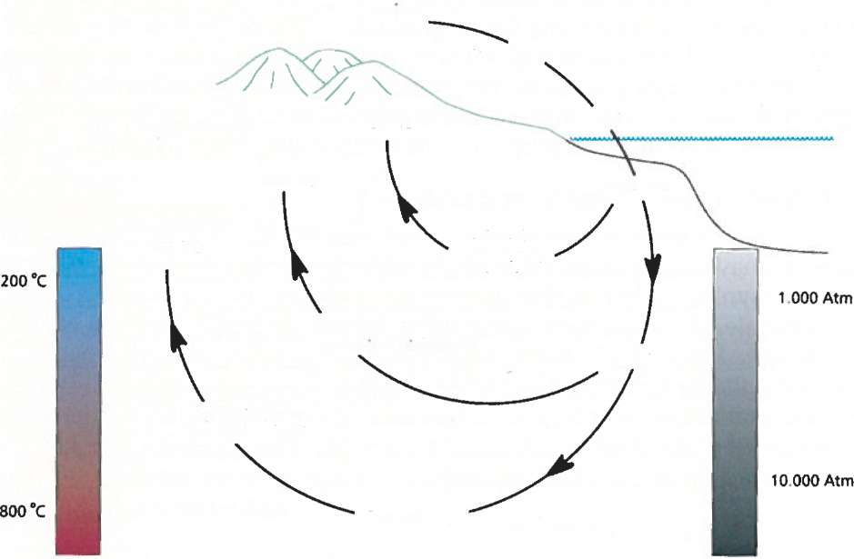  Sediments  e.g. sand, gravel, clay, limestone, salt  Sedimentation  Diagenesis  Metamorphosis  Melting  Metamorphic rock e.g. gneiss & schist  Magma species  Transport  Rising  Erosion  Rising  Rising  Figure 2.06: Mountain Species circuits and recycling of crust material [Inga, 2009]  In Denmark, the bedrock is only present and visible in the upper soil layer on Bornholm. In the rest of Denmark are only loose materials of bedrock visible, however richly present in the form of the many loose rocks and boulders transported here from the bedrock in Norway and Sweden of the ice age glaciers.  Whichever of the above formation methods that is valid for a soil or rock, the structure is always based on minerals. A mineral can be defined as a solid inorganic chemical compound that is formed from natural processes. In total there are described in more than 3,500 different minerals, but only approximately. 20 of these are commonly occurring. Directories in Figure 2.08a and 2.08b show the names and characteristics of the most common minerals.  Rocks and minerals can disintegrate, i.e. they can degrade and disintegrate into smaller units and finally perhaps completely dissolved. Since there is nothing that are lost in the nature, the chemicals degradation products from one mineral, will however, provide a basis for formation of other minerals that are better adapted to the current geochemical and physical conditions at the weathering site. A good example is the clay minerals that occur at the earth’s surface based on for example the components released by weathering of feldspar and dark minerals in granite. All soils in nature is participating in a global recycling scheme, see Figure 2.07.  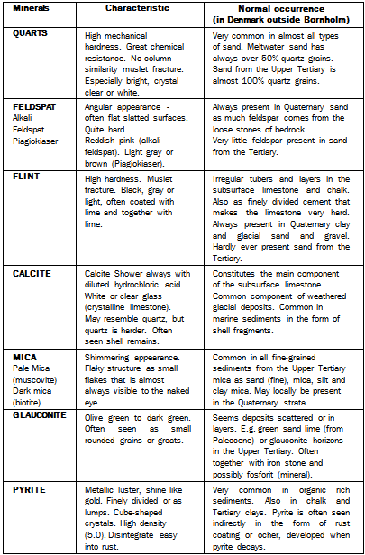  Figure 2.08a: General minerals in Danish soils.  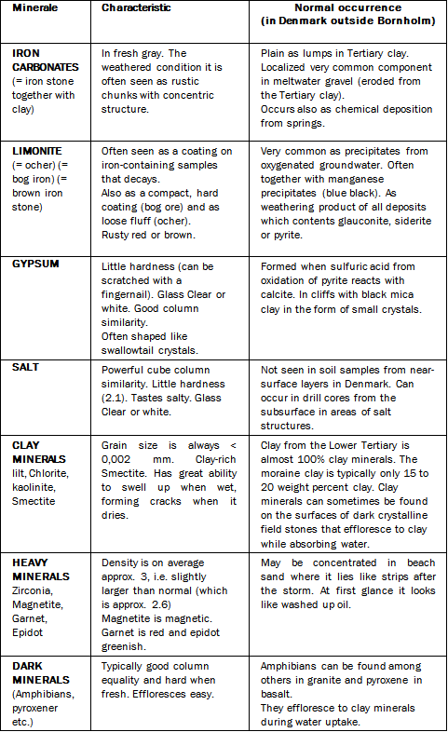  Figure 2.08b: General minerals in Danish soils.  Generally about classification. The natural soil and rock in Denmark after their main components are grouped as shown in Figure 2.09a and 2.09b.  Each group is divided into a number of variations depending on the deposition environment where the soil is formed and during which geological period the deposition or formation occurred. These variations are shown in middle column in Figure 2.09. Determination of a soil-species-deposition-environment and geologic age is typically performed by looking at the geological map of the location where the sample was taken. If possible, one also surveys the sample site in the local succession i.e. what lies above and below the type of soil. The following section characteristics and performance of individual divisions of earth and rock. Occurrence and distribution and geological affinities are only sporadically discussed, since it lies outside the scope of this paper.  Stone and gravel These two component groups are described here together, because in nature almost always occur together. Stones and gravel are defined by their grain size that is be larger than 2 mm. (See Chart 2.06) In addition, further fractionation is not defined in road construction and concrete technology. Here you go directly from sand to stone, but in return the stone fraction then divided into several subgroups, such as grit, peas, nuts and more.  Generally consisting of individual stones and gravel grains of a fairly mixed material, as ice and melt water has eroded out of bedrock in Scandinavia and Denmark’s own underground. All flintstone is residue from the ice and melt water erosion into the static limestone subsoil in Denmark.  Among the stones and gravel particles may be porous flint and sporadic rotten stone, consisting of e.g. weathered bedrock rock clay-iron-stone. For construction purposes, these stones are undesirable and therefore we try to sort them by when producing sand and gravel. See materials, abstracted from the seabed, typically contain very few grains of porous flint and rotten stone.  Sand. The grain size of sand is between 0.06 mm and 2 mm, and even the smallest grain is visible to the naked eye. Grains may consist of many different minerals, as in the case of glacial sand. Sand can also be very uniform and consist of a single mineral, as is the case with quartz sand. Specifically, it can also consist of sandy limestone grains along with green glauconite grains is the green sand, for example known from the Zealand. Part of the volcanic ash layers from the Limfjord area diatomite is also technically classify as sand as the individual grains in the ash lies in the fine sand fraction - grit.  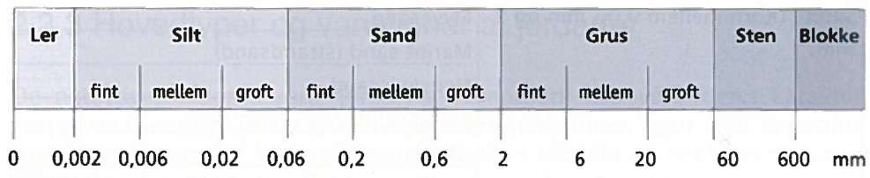  Clay Silt Sand Gravel Rock Blocks  fine medium coarse  fine medium coarse  fine medium coarse  Damp sand is slightly moldable, but one cannot roll a tube out of it, as is the case with clay and silt. Dry sand lacks internal consistency and is completely loose. The upper Danish soil layers are usually sandy and loose unhardened. On Bornholm, there are however two types of very old sandstone, where the sand has hardened into respectively Nexø Sandstone and dotted Bispebjerg sandstone.  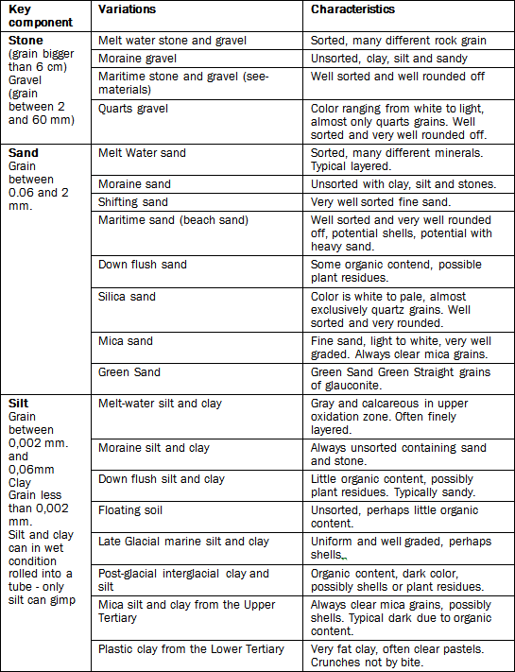  Figure 2.09: Over Danish soils - sorted by major components  Clay and silt. Clay and silt are defined by their grain sizes, as shown by the scales in Figure 2.06. Despite the difference in grain size, clay and silt has some common features that make it natural to treat them as one group in structural and foundation purposes. The common characteristics of clay and silt are:  - The individual grains of clay and silt cannot be discerned with the naked eye.  - Silt and clay is malleable and sticky when wet - you can roll a tube of it (clay can be rolled to thinner tubes than silt).  - Silt and clay are particularly solid and hard when dry.  - Clay and silt have poor permeability but high capillarity (hair pipe effect).  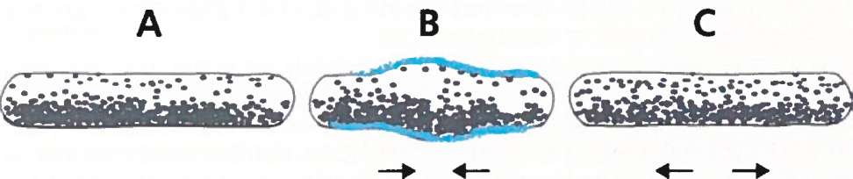  Figure 2.10. Gimp tests to identify the silt. A rolled sausage of silt (A) will regain its shape when making small harmonica movements (B and C) - a clay sausage is "dead" and will not show this elasticity.  The capillarity makes that the pore spaces in clay and silt will always be completely filled with water, apart from drying zone in the topmost zone near to the top ground.  The characteristic differences in clay and silt are:  - Silt can gimp – clay cannot (gimping is shown in Figure 2.10).  - Silt can in dry condition usually be brushed off ones hands – clay’s grain is so fine that it goes into the palm pores, so you must use water to get it off your hands.  - Silt has a matt cutting surface and clay has a polished cut surface - the shinier the cutting surface; the fatter clay.  The so-called gimp experiments is performed by rolling a tube of comfortable wet material (Number 1 in Figure 2.10) and hold the ends of it while performing concertina movements (No. 2 and 3 in Figure 2.10). If the material consists mainly of grains in the silt fraction the tube will respond as soft elastic and regain its original shape by the movement. A clay tube will not regain the form. It is very characteristic that tubes of silt are blank on the surface when it pulls itself together and matt when it pulled out. This is because water moves fairly quickly in the pores.  In the immediate assessment of a type of soil, formability in wet condition is a crucial criterion. Formability is also present although a sample containing only 15 to 20 percent of clay fraction. This means that a sample might be clay, although up to 80% of the sample in fact consists of grain fraction silt and sand.  Clay’s fatness reflects the proportion of grain in the clay fraction ie. grains with diameters less than 0.002 mm. Clay’s fatness can also be expressed by clay plasticity - a very rich clay has a high plasticity. The guiding objective of clay’s fatness or plasticity is the ratio of smectite minerals in the clay sample. Smectite is one of the four groups of clay minerals, as evidenced by mineral form in Figure 2.08a and 2.08b.  Fat clay swells and shrinks depending on soil moisture content. Therefore it is problematic to think about very fat clay, as the clay by water absorption can lift structures and cause traction even at very small inclinations. By drying clay hauls itself together, and on a dry summer it can cause subsidence damages to building, which are constructed on fat clay.  Vegetable Mould (top soil). Mould is a type of soil that naturally evolve if the climate and chemical conditions in the soil otherwise is to it. There are always live microorganisms in natural soil, and there is a constant turnover of the organic substance found in soil. Mold is easily recognizable on the dark color and the loose crumb structure.  Organic silt. Organic silt consists entirely of comminuted organic matter where it is no longer possible to recognize which plants or animals that originally supplied the organic matter. Earlier organic silt was described as silt, a name which, however, still is used in many contexts of organic sediments. Deposition of organic silt happened in water. Therefore, the discovery of an organic silt layer always shows that spot has been a lake or a fjord – provided that the organic silt layer not has been moved after the original deposition.  Organic silt may resemble clay and silt, but it can be recognized on the following traits:  - Organic silt has a lower density than clay and silt.  - Organic silt has a distinctive, slightly spongy texture that can resemble yeast.  - Fresh organic silt may have a slight odor of sewage.  - The color can vary but is usually dark, possible greenish.  For all building and construction projects, it is very important to identify organic silt because it is subsidence-making, due to its poor bearing capacity.  Peat. Peat is like organic silt of organic matter, but peat has unlike organic silt visible residue of wood or plant structures. There is a smooth transition between peat and organic silt, and sometimes it can be difficult to determine if peat or organic silt constitutes the main component in a given soil sample. Typically you will find peat on top of organic silt, indicating that a lake with free water surface has gradually grown with reeds and eventually perhaps becomes a meadow.  Coal. Peat and organic silt can by increasing pressure and temperature hardened into coal. In Denmark as lignite (brown coal) partly from Central Jutland and partly from Bornholm. The central Jutland lignite is from Upper Tertiary period, while the Bornholm lignite is from the much older Jurassic period.  Individual coal beds in central Jutland is typically less than 1 m thick and surrounded by layers of fine sand, mica silt and quartz sand. In the time before and especially during Second World War II were mined large quantities of brown coal for fuel. This production is in Central Jutland continued up to mid-1960s.  Lime. Soils with the lime calcite can always be recognized that the drizzle by adding diluted hydrochloric acid. It is the gas of C02, which drizzles’, since C02 is formed when hydrochloric acid (HC1) combines with lime (CaC03). Limestone occurs in a number of variations, as shown in Figure 2.09. Characteristics of the different variations are related to hardness, grain size and structure. Cretaceous (also called lime sludge) is an old term for a soft, white, rub off variation of fine-grained limestone.  A hard limestone is typical, in certain areas, quite fractured and highly water-bearing. Therefore, it can be troublesome having to make a groundwater lowering activity at a construction pit in limestone, since the inflow may be so large that it requires a very strong pumping capacity to keep the pit free of water. In Denmark, especially static limestone near ground surface is found in a belt from Hanstholm, Thisted, Aalborg over northern Djursland to the Copenhagen area and down over Fakse, Stevns and Moen.  Diatomite. The soil type diatomite is relatively rare in the upper soil layers in Denmark apart from the area around the Limfjord. Here, on Mors and Fur is a considerable abstraction of diatomite. Outside the Limfjord area there are scattered deposits of diatomite (- diatomaceous earth) that is formed as lake deposits in between ice ages. Diatomite is like lime but may be distinguished from this by not drizzling when diluted with hydrochloric acid. Another important characteristic is the low density obtained because diatomite consists of air-filled shell material.  Chemical precipitation. Despite the chemical precipitation rarely constitutes the main component in a type of soil, they nevertheless included in a list of Danish soils, as they locally can be very dominant. Flint can thus act as a coherent layer of limestone. Where transport by Meltwater Rivers or coastal erosion has decomposed large quantities of limestone, rolling flint also can be concentrated after all the limestone is eroded and washed out. This is, for example the case for Glatved in Jutland.  Secondary calcium precipitates in melt-water gravel and sand can lead to that loose sand and gravel suddenly is acting like a hard rock, all the grains are held together by the precipitated calcium. Hence, for example at a hillside near Hadsund in Jutland, can be seen a natural type of soil, very similar to concrete. The so-called cement rock in the Limfjord area is also an example of a secondary chalk deposition; here volcanic ashes and diatomite cement together to a characteristic streaky, hard rock.  Clay iron stone, which mostly consist of FeC03 (siderite) is like tubers common in the fat clay from the Lower Tertiary. These tubers are often seen in weathered form as rusty rock in rock and gravel deposited by meltwater. Oxidized iron and manganese compounds can cement sand and gravel into hard layers and bands - especially where the sand is adjacent to a clay layer.  Bedrock rocks. In Denmark static rocks can only be seen on the island of Bornholm. However, the bedrock rocks dominating both on Greenland and the Faroe Islands and therefore works in hard rock are not unknown for Danish contractors. Due to the high hardness blasting is frequently used when excavation.

2.5 Earthmoving
2.5.1 General  2.5.2 Mass Curve  2.5.3 Mass disposition  2.5.4 Transport logistics  2.5.5 Transport cost | Earth-moving includes operations where the soil is dredged and loaded onto transport vehicles and then being moved and built as filling. If the soil is in surplus or unsuitable as backfill, it will be discarded and unloaded on a side tipping. Mould to be used for coating the slopes, etc., are placed in escrow and laid out when earthworks nearing completion.  Excavation of soil takes place, where the roads plane and any possible ditches should be in the excavation, I. lower than the existing terrain. Definition of the plane is the soil surface to serve as a base for road construction. As well too removed earth to make way for construction of basement, bridge foundations and the like. On sections where the topsoil is composed of non-sustainable or subsidence hazardous materials such as peat and organic silt, makes often a soft bottom replacement. Finally having retrieved foreign fill materials from a side intake - if there is a shortage of suitable fill materials from the excavations recently conducted.  Mold Earthworks needs to be scheduled separately. Removing excavated soils that cannot be used as filling and also releases of any soft bottom deposits is also planned as separate topics, as there are no longitudinal moves along the projected stretch.  As well as excavation and fill shall be designed and executed in a manner that is consistently established an efficient drainage of both precipitation and groundwater. Soil surfaces must be kept so regulated and compressed, that surface water runoff and soil is not soaked in the event of rain. When operating with machinery and transport vehicles, traffic must be distributed evenly over the surface so that there are no deep wheel tracks.  The following Figure 2.22 shows an excavation, where some soil A should be dredged and moved away and filled in a hollow, P. Transport Work T can be expressed as the product of A and T, where T indicates the center of gravity distance. To assess and minimize this work one sketch a so-called Mass Curve.  Figure 2.22: Transport effort  The result of a soil calculation is illustrated graphically in a mass diagram where excavations and filling volumes are plotted as bars in a coordinate system where the abscissa axis indicate the road line stationing. The same yardstick for stationing as the road profile is used so that the two shapes can be easily compared, see Figure 2.23. By summation over through the line of all volumes beginning with directories created the so-called mass curve, see Fig. 2.23. It is assumed that all excavated soil can be used as filler.  Mass curve indicates at any station soil surplus or deficit to the left before the station. Since the mass curve is a sum curve, it follows that:  - M > 0 means land surplus (resulting excavation to the left of the station).  - M < 0 Means soil loss (resulting filling the left of the station).  - M = 0 means land equilibrium (excavation equal filling the left of the station). This is called a balancing point.  - M growing shows that soil is excavated.  - M decreasing shows filling with soil.  - M is maximum at the end of an excavation, i.e. where excavation switches to filling.  - M is minimum at the end of a filler, i.e. where filling switches to excavation.  - Ordinate difference between two stations indicates the resultant excavation or filling between two stations.  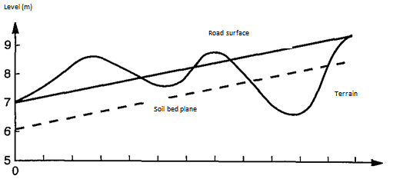  Length profile  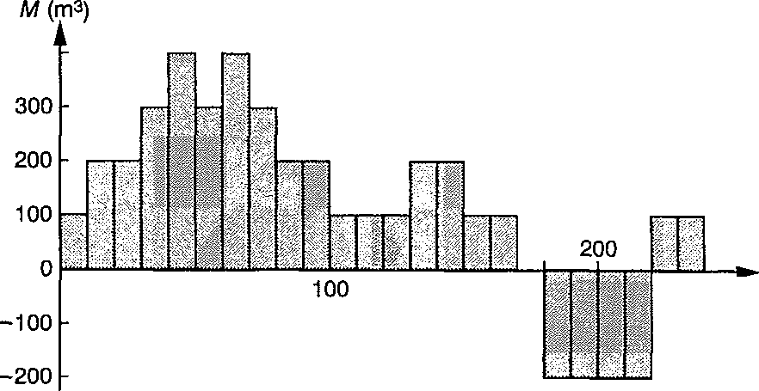  Mass diagram  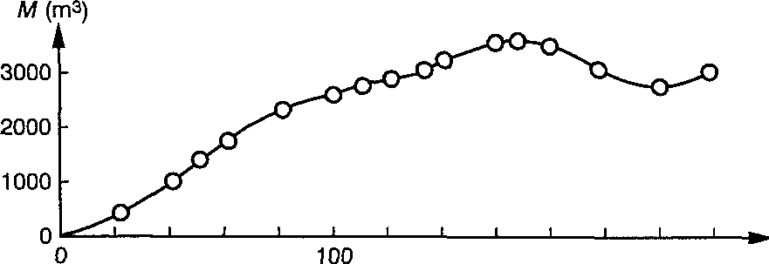  Mass curve  Figure 2.23: Length Profile and similar mass and mass diagram curve of a road section. Figure courtesy of Bent Thagesen: Lærebog Veje & Stier.  The mathematical fill volumes must be corrected by multiplying by the compression factor. Mass curve indicates a graphic overview of soil moving amounts within in the whole road. It indicates how much soil to be dug or back filled in each section, e.g. between compensation points. The ideal mass curve has many countervailing points along the way, since this means short transport distances, and usually it is small soil masses moved. Closes mass curves not at the end, there is either a surplus or deficit of soil.  When consideration a mass curve one should not be confused by the fact that it always starts at 0. It is the effect of the summation that starts at this point. Similarly, the fact that a surplus or deficit of soil evident by the mass curve does not close at the end, does not mean that it is precisely here that the surplus or deficit arises.  The actual construction of the mass diagram is performed as follows:  - Apart from road profile determined with fixed stationing intervals an array of sections whose filling and excavation intervals calculated. Multiplied by interval length often set to 20 m one gets how many cubic meters of soil to be side moved, added or removed within each stationing interval.  The result of a soil calculation can be expressed as shown in Example 2.01.  Station m Excavation m³ Filling m³ Side move m³ Mass curve m³  7180 2192 146 75 2338  179 170 170  7200 2371 316 245 2347  27 508 27  7220 2398 824 272 1866  Example 2.01: Soil calculation.  Here is side moving the amount of soil to be moved within a stationing interval, while the mass curve formed by the summation of the resulting soil volumes to be removed or added stationing intervals. Mass curve ordinate M = S resulting excavation volume X resulting fill volume.  At the mass curve, Figure 2.24, you can learn for example that between A and B shall dredged a certain amount of soil equal to the height difference hab. The equivalent soil amount shall be filled with area CD, i.e. moving becomes a trapezoidal area between AB and CD. Moving Average distance for all soil works from A to B can either be evaluated graphically or calculated as a mass curve area with longitudinal axis divided by the maximum ordinate equivalent to the equates mass curve with a rectangle of the same area.  By mass disposition (mass planning) is understood a planning from where and to where the movement of soil masses in relation to the excavation work. The project engineer uses mass disposition as the basis for drafting a preliminary estimate of the cost of soil moving. The contractor uses mass disposition of bidding and planning of the work. Only the contractor can make the final mass disposal, as it usually is he who decides which machines to be used.  Implementation of a mass disposition requires knowledge of:  - Mass curve.  - Occurrence of unsuitable soil.  - Transportation.  - Transportation costs as a function of transport distance.  - Transport Roads.  - Disposition Method.  The principle of the traditional mass disposition is shown in Figure 2.25  Figure 2.25: Mass disposition.  The recorded mass curve stratifies the basis of knowledge of the move distances, where particular earth-moving equipment works most economically. After such a simple method is calculated how many cubic meters of soil, which in total must be moved within any given distance intervals; the arrows indicate the moving direction. This result is contained in the tender documents and contractors will often offer based on a cost which is simply the sum of the transition to move the quantity multiplied by a moving unit cubic meter for each distance interval.  The example in Fig. 2.25 shows a mass curve, where there is a surplus of soil. To create move balance one can then, either through one or more lateral moving, remove the excess by which the mass curve then will have a vertical leap downward into those stations, or one can change the longitudinal and thus seek to close the gap by a new mass curve.  The mass curve intersection with abscissa axis indicates the stations where there is equalization. Intersection points are called equalization points and abscissa axis is called the main distribution line. A horizontal line tangential to the internal minimum or maximum defines sub-regions with equalization and is designated as a secondary distribution line.  Difference between maximum and minimum ordinate in a moving field indicates the total amount of soil to be moved to this area. The length of the moving field indicates the maximum transport length of the field. Usually the biggest transport length is uninteresting, as one will seek an average moving distance to optimize the transport equipment.  You can also use the mass curve nontraditional for mass disposal, as shown in Figure 2.26.  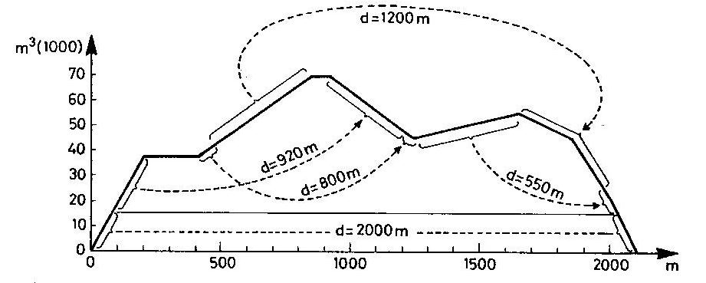  Figure 2.26: Mass disposition from one type of equipment.  Here one can calculate that the average moving distances are well 1200 m in length, suitable for motor scrapers. Then it is decided to use this material type and mass disposition is, as shown, sought solved by the majority of the soil is moved between 800-1200 m, which is economical for the scrapers.  Transport of suitable fillers will often take place along the future road. Construction of bridges, tunnels or other may prevent longitudinal movement, and also other factors can lead to a different and more complex transportation logistics. In some cases it may be advantageous to replace a longitudinal moving with a side dump near the excavation and a side borrows near filling. The number, location and capacity of side borrow and side dumps are of great importance for the outcome of the mass disposition.  Mold soil works must be planned for themselves. This can be achieved by mapping a special mass curve. Removal of soil excavation that cannot be used as filling and release of any soft bottom deposits also requires independent planning, but here is no question of longitudinal moving along the projected road. Transportation to and from the side dump is usually along existing roads.  Costs of transporting a quantity of soil a given distance will depend on what equipment is available. The price per cubic meter of soil transported, in principle increase with distance, but the exact cost varies from contractor to contractor.  Figure 2.27: Cost curves.  In the above figure 2.27 shows how a relationship between price and transportation distance will look like for the ordinary equipment types. The curves form is calculated from excavation and transport, where installation, leveling and compression are excluded.  Costs are as shown in the figure depending on the material type used in the different move distances, but prices are dependent on the factors involved in an equipment rental calculation, such as replacement value, durability, interest rates and employment opportunities. Even within the same material type and with a determined move distance, there are large price variations; normally it is due soil conditions, how difficult it is to work with and whether there are small or large amounts of soil. This will eventually influence the choice between small or large equipment. In general, if there is plenty to do for a machine, it is cheaper to select it as big as possible.

2.6 Production
2.6.1 General  2.6.2 Production Formulas  2.6.3 Efficiency factors | Manufacturers of construction machinery generally supply diagrams of the individual machine, performance depending on bucket size, type of soil, digging depth, oscillation angle and so on. For moving vehicles, production is calculated on the basis of the volume per wagonload and number of loads per hours.  At the theoretical soil work and study measurements one considered time as per revolution or orbital cycle or circulation, i.e. the time from it is in a given position, and it is back in this position.  At subsequent Figure 2.28 shows a revolution for a dump truck.  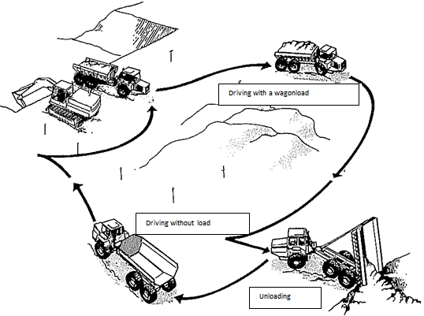  Figure 2.28: One revolution for a dump truck.  Circulation time divided into a fixed orbital period in minute’s t_{f} and a variable orbital t_{v} also in minutes. The fixed orbital period is independent of transport distance. It covers the time it takes to load, unload, turn and accelerate through the gears, and is usually also dependent on soil type. The variable orbital period is dependent on transport distance and road speed. Number of loads per hour A can be expressed as:  Formula 2.13: 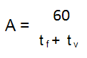 Formula 2.13  Vehicles are driving at different speeds out (V_{out} with load) and home (returning empty at the speed V_{back}). Transportation distance out and back may well be different, so these are listed separately in the formula 2.14  Formula 2.14: t_{v} = $\frac{Lout}{Vout}$+ $\frac{Lback}{Vback}$  The theoretical production P_{t} in cubic meters per hours for a piece of machinery such as excavator, dump truck or the like can now be expressed in theoretical production formula:  Formula 2.15: P_{t} = V-A  Where V is the volume that is moved per cycle and can be expressed in loose or fixed units. Using loose units e.g. it correspond to the volume of the bucket contents of an excavator or the volume of loaded on a truck. As shown in Figure 2.29, bucket amount of an excavator can vary with how full the bucket is.  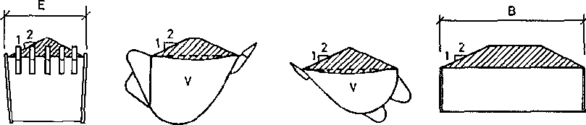  Figure 2.29: Heaped units  The correct way to set the bucket content in is one level unit V₀, i.e. mathematical volume corresponding to a maximum liquid content. Filling factor is then defined as:  Formula 2.16: f_{c} = $\frac{Vl}{V0}$  Where V_{L} is the current contents of m³ of loose units set as m³_{L}. As guidance for various materials tilt angles, see Table 2.05. If the production is wanted in specified fixed units, expressed as m³_{F}, one can multiply the performance of fixed units with the aforementioned load factor k_{I} therefore:  Formula 2.17: m³_{F} = k_{I} * m³_{L}  Loose weight kg/m³ Tilt angle  Mould, plain soil, normal moist 1700 25°  Sand and gravel, moist 1800 30°  Sand and gravel, wet 2000 27°  Singles, predominantly boulders 1900 30°  Blasted rock, crushed rock 1800 40°  Clay, moist until 4 m height 1500 25°  4 to 6 m height 20°  higher than 6 m 17°  Table 2.05: Tilt angles.  Sometimes you see the expression filling ratio, which is the product of load factor and filling factor:  Formula 2.18: f_{g} = k_{I} * f_{c}  This means that you direct get the production volume V in solid units by multiplying the level measuring V₀ with the filling rate f_{g}:  Formula 2.19: V_{F} = V₀ * f_{g}  In Table 2.06 are listed examples of filling rates for different soils with different soil machinery.  Type of soil Dozer Motor scrapers Transport vehicles Diggers*  Turf 0,70 0,65 0,80 0,75  Mould 1,10 1,00 1,15 1,10  Sand, dry 0,65 0,70 1,10 0,90  Sand, moist 0,90 0,90 1,20 1,05  Gravel 0,75 1,00 1,15 1,10  Clayey sand 1,50 1,10 1,10 1,10  Clay 1,30 1,10 1,10 1,10  Clay, hard 0,80 0,70 0,90 0,80  Marl 1,00 0,70 1,00 0,90  Rock 0,55 0,75 0,75 0,75  * For diggers with bucket figure reduces by a factor 0.8  Table 2.06: Filling rate f_{g}  The theoretical production formula is equivalent to 100% efficiency. The practical production formula is:  P = V*A*C Formula 2.20  Here C is an efficiency factor, which is composed of the product of several different factors, whose size is one must determine in each case. Some factors are general and are listed below, while others specifically attributable to the various types of machinery and therefore are described there. The general factors relating to personnel, the conditions under which work is performed, the construction method chosen and an equipment general maintenance mode. P can be defined as operational production and the time needed for this: The operating time.  People factor k_{p} is an expression of small breaks and precision of the operator and can usually be set to 50 minutes of each hour, i.e. 50/60 = 0.83. Where two machine operators are interdependent, e.g. excavators and carriers, the personal factor k_{p} attributable to both machines, since there is one operator on each machine.  Qualification factor k_{f} is a numerical factor assessed from the driver’s skills. Following specified experience figures can be assigned:  Qualification Factor k_{f} Qualification Factor k_{f}  Expert 1,33 Just under 0,95  Master 1,20 Satisfactory 0,90  Skilled 1,15 Sufficient 0,85  Good 1,10 Poor 0,75  Just over 1,05 Trainee 0,60  Average 1,00  Table 2.07: Qualification factors.  Calculations show that the qualification allowance operator champions receives is quite modest compared to the large economic gains associated with a higher performance.  Visibility factor k_{s} are a reflection of reduced work rate and can be set to 0.8 when there is snow, fog or twilight.  Coupling factor k_{k} used in cooperation between two or more machines, e.g. in the case excavator and carriers, where you can set k_{k} = 0.9, and is here expressing the time required for the placement of trailers. The subject coupling factor is later discussed in more detail under the section transporters.  The works arts factor k_{g} depends on whether the excavator can operate freely within the same area for longer periods or must constantly move to new positions. Also establishes k_{a} based on whether the soil is difficult to handle and if the bucket cannot be completely filled each scoop. When backfilling it is often the case that we must approach cautiously due to structures that shall be soil covered. One has indicatives of k_{a}:  Average Max  Optimal operation: Large construction pit, working in quarry 0.80 1.00  Spatial constraints, small construction pit, large ditches 0.60 0.80  Backfilling 0.55 0.75  Trimming works 0.50 0.70  Tight spatial constraints: Excavations at buildings 0.45 0.60  Table 2.08: Nature of work k_{a}  Machine Jam Factor k_{ms} Engine Stop over longer periods (more than 3 weeks) is likely due to mechanical damage. Factor is set to k_{ms} – 0.9. In Western Europe, this factor is valued to be of modest significance and should be evaluated whether it has an impact on the total value of C, since access to the replacement engine by engine failure almost always is present within a few hours.  Loading efficiency factor k_{le} is a factor that for excavators expresses how easy it is to get rid of the soil again:  Positioning the excavator Factor k_{le}  The excavator are placed over the carriers plane 1,00  The excavator loads from the same plane as the carriers are in 0,90  The excavator are placed under the vehicles plane 0,80  Loading in a construction pit 0,67  Loading in a silo 0,58  Table 2.09: Load Efficiency Factor k_{le}  In figures 2.30 and 2.31 are illustrated some examples of classification of loaders and dumpers.  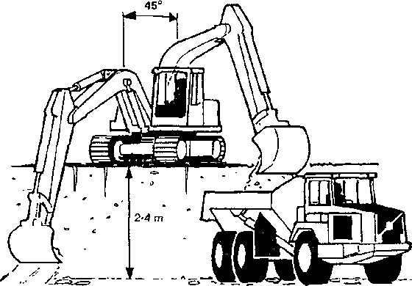  Figure 2.30: The excavator is placed over the carriers’ plane.  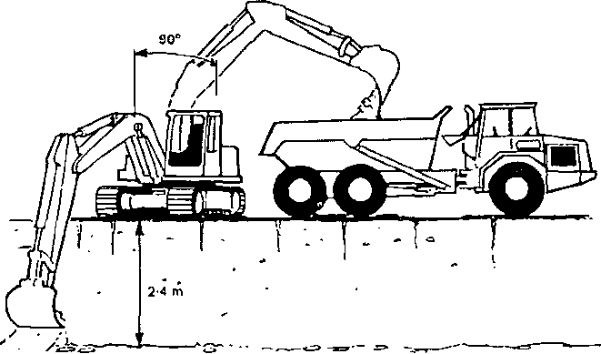  Figure 2.31: The excavator loads from the same plane as the carriers are  Efficiency factor C. As shown in previous pages can factor C be composed of:  Formula 2.21: C = k_{p} * k_{f} * k_{s} * k_{k} * k_{a} * k_{ms}* k_{le}  The amount of C has a huge influence on how much practical throughput will be. Therefore it is in the planning of the excavation work very important to seek the maximum value for C and hence to get the maximum throughput out of a given fleet.  Month Digging Transport Building-in Result  January 5 10 1 1  February 5 10 0 0  March 15 5 5 5  April 20 10 11 10  May 20 15 16 15  June 20 18 18 18  July 20 16 16 16  August 20 17 17 17  September 20 17 15 15  October 20 14 7 7  November 10 10 0 0  December 10 7 0 0  Table 2.10: Possible effective working days.  Finally throughput is reduced since there wastage days occur because of inclement weather which reduces production. This is especially true when working in cohesive soils containing clay and silt. They are very moisture sensitive and sludge easily, which is a great nuisance to land transport.  Danish Contractors has on the basis of completed questionnaires obtained a planning basis (Table 2.10) of available working days on year in the upper moraine silt, without any particularly weather precautions. On average, it is only the month from start April to late September which can always be reckoned as the primary soil work period.  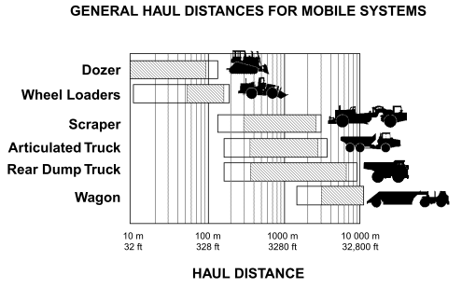

2.7 Earth machinery
2.7.1 General  2.7.1 Dozer  2.7.3 Loaders  2.7.4 Excavator with towing shovel  2.7.5 Hydraulic excavators  2.7.6 Motor graders | Machinery is available in various types and each are designed for specific kinds of soil work. But they can also be used for something else in special cases as with small amounts of soil, where it will be too expensive to replace one machine with another more suitable machine, e.g. soil can be transported with a conventional excavator, although it is built to stand still and dig. Often, each type is available in 2 versions, with rubber wheels or caterpillar tracks, where one must choose between high speed and maneuverability in difficult terrain. We can provide equipment for the following types:  - Stationary equipment types the mentioned general excavator that stands at the same place and excavate e.g. a construction pit, and who must deliver the soil alongside and let other equipment to carry it on. For this type of machine include hydraulic excavator’s height or backhoe plus the wire-operated excavators, tug bucket or bucket.  - Movable equipment types as dozers, loaders, scrapers, graders, backhoes, which loosen soils, transports and unload somewhere else. These equipment types are each most economical move at certain different distances.  Transporters as trucks, dumpers and dump trucks that do not load themselves, but is loaded by an excavator and can only drive and unload.  Each machine type is again available in different sizes. But you cannot count on all types and sizes, is available locally or in a single country, because there is not always enough work for large and special machines and equipment.  The Dozer is as shown in Figure 2.32 usually a tracked vehicle equipped with a dozer blade that pushes the material before it or by angling the blade in the direction of travel lets it slip to the side. The commonly used as earth-moving equipment at shorter distances, i.e. below 100 m.  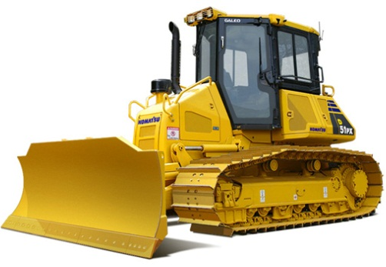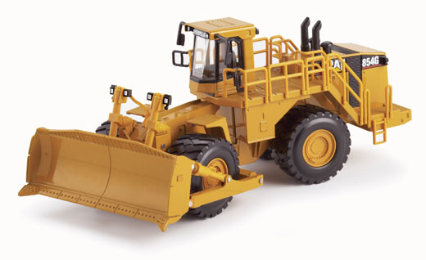  Figure 2.32: Caterpillar dozer end Rubber wheel dozer  It is used to topsoil evacuation and land clearing, site preparation, pushing tractor scrapers, leveling access roads for carriers, and smoothing surfaces around buildings, filling trenches and equipped with a ripper, breaking up hard soil that does not immediately can be excavated.  The dozer can drive straight forward and backward and turn by driving more with one belt than the other. Sharp turns are made with one belt completely out of function and used as center of rotation, while there is full drive on the other belt. Very sharp turns can be achieved by custom-built machines used for example at tunnel works; here the belts rotate in opposite directions so that the focal point now lies in the middle of the machine.  You can also get dozers on wheels, but they are very sensitive to soils in terms of being able to maneuver and withstand on demanding works. But they are faster and can be used economically over longer transport distances and can carry itself along the roads out to the site where the other dozer, as all tracked vehicles, must be transported on flatbed truck.  The dozer is equipped with a heavily constructed steel blade that pushes the material before it with backstop created by the drive belts grip in the surface.  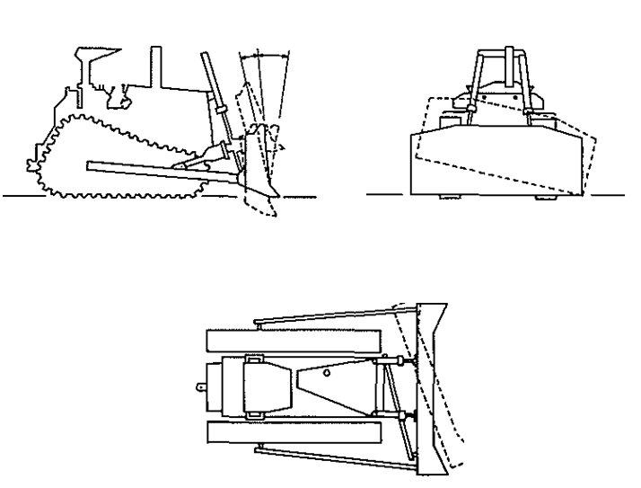  Figure 2.33: The dozer blade movement possibilities.  Dozer blade can be lowered below ground level when the soil must be peeled off and pushed away, and lifted above ground, while the dozer still runs forward so that the earth is laid out and gets a first compressing by the dozer. In addition some machines can be equipped so that they can tilt with the blade on a horizontal or vertical axis or skew (angle) in the direction of travel. When using tilt increases the dozers opportunities for excavation and shaping the terrain more, and by angling the blade, you can let the soil loosened, slide to the one side, just as the leaf position is sometimes used by backfilling trenches. Dozer blades can be designed in various ways, but for mostly they are curved in cross section, as shown in Figure 2.34.  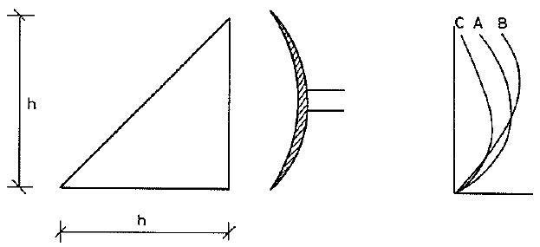  Figure 2.34: blade and its filling volume on level.  S-blade. S-blade - leaf profile B - is the most common and all-round there is. It only curves in one plane - cross section - and is otherwise even throughout the leaf length. It has a high refractive power (kN per m of the cut). It can handle most soil types, but because of the decrease (loss of land to the side during ground movement) it is most economical on shorter distances. Side loss can be reduced by slot dozing where you gradually dozer down in the same groove, so that the soil banks holds the dozer soil in place. With side dozing large areas are leveled by allowing multiple dozers run side by side.  U-blade. U-blade - leaf profile C - is double curved, i.e. longitudinal direction tends to form a U formed by a straight middle piece and two 25 ° angled blades. The advantage of this leaf is that it keeps better in the soil and therefore is especially suitable for transporting large quantities over long distances with little side loss. Breaking ability is not as big and U-blade is therefore best suited for light soils. When mounting a tilt cylinder on the leaf it can revolve a bit around a horizontal axis and thereby improve the breaking abilities.  SU-blade. As the name indicates it is an attempt to compromise between the S and D blades advantages. It has the same height, width and curvature as an S-blade, but volume is increased by adding wings as on U-blades only smaller, or providing it with an end bulkhead that holds the soil. Breaking ability is good, but is not as suitable as the S-blade for distributing soil in finish works and leveling. Equipped with a trust plate the SU-blade is suitable to support scrapers during loading.  A-blade. A-blade - leaf profile A - can be like the other leafs kept perpendicular to the direction of travel, but may be tilted (angled) up to 25 degrees. This makes it ideal for side moving, clearing and backfilling of lighter soils, but no rocks or the like. Production with angled leaf is only approx. half of a comparable even leaf.  C-blade. C-blade has the same curve as the U-blade, but is straight as the S-blade, i.e. without wings. It is smaller than the other leaf types and is installed on larger dozers when pushing on scrapers when they shall be filled. Blade is equipped with rubber coating to dampen the collision with scrapers. C-sheet can also be used for normal duty work such as regulation of the workplace around scrapers.  Special blades. In addition a number of blades for special purposes are available such as blades for mining of coal, leveling, waste management, deforestation and clearing of farmland.  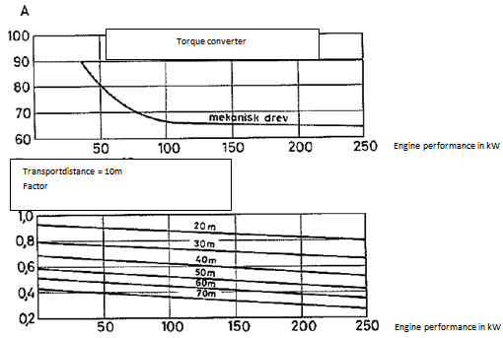  Figure 2.35: Number dozer loads per hour.  The dozers performance  To determine the dozer performance is the production used formula (see formula 2.20)  P = V*A*C  Herein the number A of revolutions within an hour for a belt dozer can be read directly from Figure 2.35 for a transport distance (moving distance) of 10 m in dependence on the dozer size indicated by the engine output in kW.  That smaller machine has more revolutions per hour than a bigger machine is not that they can drive faster, but because they are more maneuverable. This applies when there is a manual transmission with mechanical coupling between the motor and gears. With the latest machines today, equipped with a single lever control (torque converter and power-shift gear) you can put in revolution figure A to 90 regardless of machine size. For others transport distances than 10 meters must be multiplied revolution numbers A for 10 m with a factor that also can be seen in Figure 2.35.  Transport volume in loose units can be calculated out from the assumption, as shown in Figure 2.34, that the dozer blades evened volume is theoretically calculated as if the soil in cross section lies within a right-angled triangle, and then corrected by a factor f due to profile shape and a factor f_{c} for filling. Then you get:  Formula 2.22: V_{L} = ½ * h₂ * b * f_{p} * f_{c}  The coefficient for profile shape can for those in figure 2.34 showed forms can assume values as mentioned in Table 2.11.  Blade profile Decription of blade Profile factor f_{p}  Profile A Constant in vertical position 0,87  Profile B Curves more and more 0,92  Profile C Decreases in the upward curvature 1,00  Table 2.11: Profile Factor f_{p}  Filling factor f_{c} can vary enormously and therefore has great important for the dozers performance. It is primarily dependent on the soils ability to withstand during transportation. To describe this one has introduced the concept of kinetic soil correlation coefficient _{B} as for different soils are given in Table 2.12.  Soil type _{B}  Friction soils  Fine sand, dry 6-9  Fine sand, moist 14-17  Coarse sand, dry 14  Coarse sand, moist 18  Fine gravel 18  Coarse gravel 25  Pebbles, small 35  Pebbles 50  Cohesive soils  Lean clay, plastic 7  Lean clay, semisolid 11  Sand mixed clay, plastic 10  Sand mixed clay, semisolid 16  Medium fat clay, plastic 15  Medium fat clay, semisolid 28  Fat clay, plastic 18  Fat clay, semisolid 35  Fat clay, solid 55  Organic soils  Very loose, sparse vegetation 12  Loose, weak grass layer 20  Semi solid, thick grass layer 40  Solid, very thick grass layer 50  Scrub and grass layer 60  Table 2.12: Kinetic soil correlation coefficient.  Filling factor f_{c} can now be specified as the product of f_{co} and f_{c}  Formula 2.23: F_{c} = f_{co} * f_{ct}  Here are f_{co} an expression of the ordinary filling, as discussed earlier, i.e. by how much top soil can be ahead of the dozer during transport. f_{co} can be seen in Figure 2.37. Here is applied transverse ratio t, which is width divided by height of dozer blade (t = b/h). f_{ct} is a correction factor for the loss to the sides that occur during transport of soil due to inconsistency coherency during movement. In Figure 2.36 is the factor specified for the straight blade S. For blades with wings or butts f_{ct} can be set to 1.0.  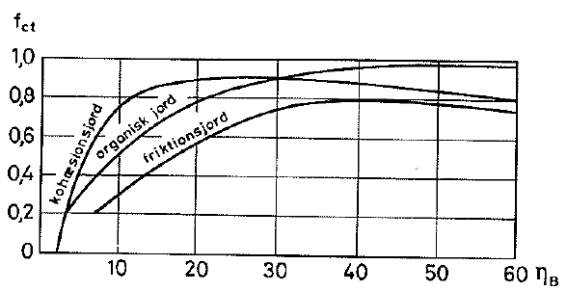  Figure 2.36: Cross Filling Factor f_{ct} (dozer blade S)  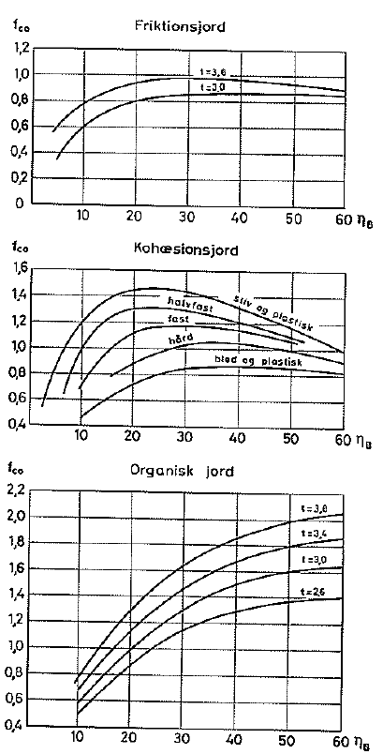  Figure 2.36: Ordinary fill factor f_{co}  The foregoing calculations dozer performance assumes that the coefficient of friction between the dirt and the machine is at least 0.5.  Is it less the performance drop. By dozing uphill falls performance by 2% per percentage increase of the terrain, while conversely increasing performance downhill by 2% per percentage increase. The belt dozer, that is most suitable on the clayey soils, has a maximum speed of between 10 and 12 km/hour depending on size. The wheel dozer, that has its force on the lighter soils where belt dozers have great wear on its caterpillar belts, have a maximum speed of between 25 and 35 km/hour. Table 2.14 shows technical data for various dozer sizes. LGP stands for low ground pressure, i.e. wide tracks.  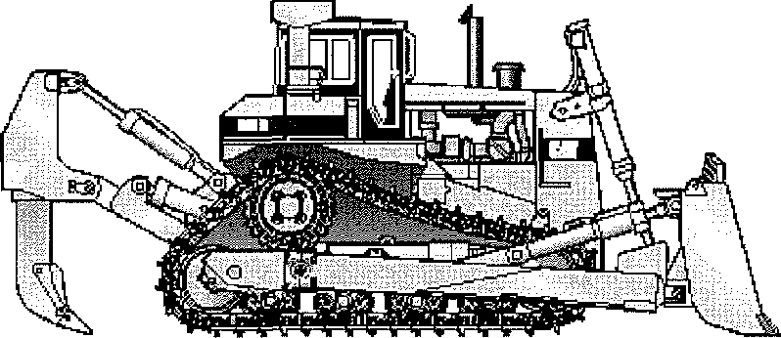  The specified machine weight is in operational condition, i.e. with oil-filled tank, coolants and driver, but no dozer blade. Digging depth and lifting height are relative to a horizontal terrain. Dozers may be using special equipment to manipulate very hard soil or rock where the excavator cannot dig or the dozers themselves have no refractive power enough to peel off. This is done by mounting one or more rips (shanks) at the back of the dozer, and with its small contact area to the soil and the dozers mechanical force can transfer large forces per unit area.  Dozer with ripper equipment  We distinguish between breaking force and down sticking force, where N indicates the power that machinery can be transfer to the tip of the tooth when it is maximum stabbed into the ground. Breaking force N represents the maximum force downward, which can be achieved at the tip of the tooth, standing on the ground when the rear of the machine begins to rise. In Table 2.13 there are some examples of such forces.  Dozer/ Ripper Ripper distance M Digging depth m Tooth number each Down sticking force kN Breaking force kN Price in 1000 Dkr.  D6R 0,73 0,50 3 66 91 100  D7R 1,07 0,75 3 87 180 150  D8R 1,58 1,46 1,13 0,80 1 3 127 124 223 228 375  D9R 1,57 1,33 1,23 0,80 1 3 154 147 321 324 500  D10R 1,76 1,56 1,37 0,94 1 3 205 205 429 429 600  D11R 2,04 1,92 1,61 1,07 1 3 318 300 619 602 650  Table 2.13: Ripping Equipment  Obviously the best way to choose dozer by performing field tests, and in order to determine the size of production, to experiment with the number of shanks, the height it must be mounted in, the angle at which to attack the soil and the depth and speed to be breaking it up with. For planning purposes it can be based on experimental results provide the following analytical expression for the dozer with single-shank:  P = 60 * $\frac{Pm 0,5}{c 1,5}$ m³_{f}/h – 25% + 50%  Where Pm is the engine power in kW and c the sound speed in m/s. An economic calculation must also include how the broken up material is removed, whether they are dozes to the side or driven away with e.g. scrapers.  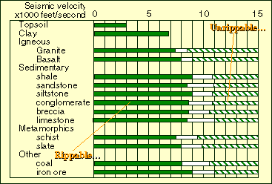  Figure 2.40: Ripping possibilities of soil with Caterpillar dozer D9-single shank ripper.  The front loader is a digging device on both caterpillar tracks (track loader, crawler or belt loader) as on rubber wheels. The crawler is a strong digging tool for solid Earth as clay (Figure 2.46), while rubber diggers are more suitable to solve the soil moves and depot building (Figure 2.44). Belt machine is of course slower and only economic up to a haul transport distance of 80 m, where wheel machines is suitable up to 200 m and also can drive on public roads without damaging them, Both machines can excavate soil from a brink in front of them, just as they can be used to dig in the soil by flat excavates eg such as a larger basement. Wheel loader has a smaller turning radius than the crawler, since the machinery is grouped into two parts around an axis on which the parts can be rotated 40 in relation to each other.  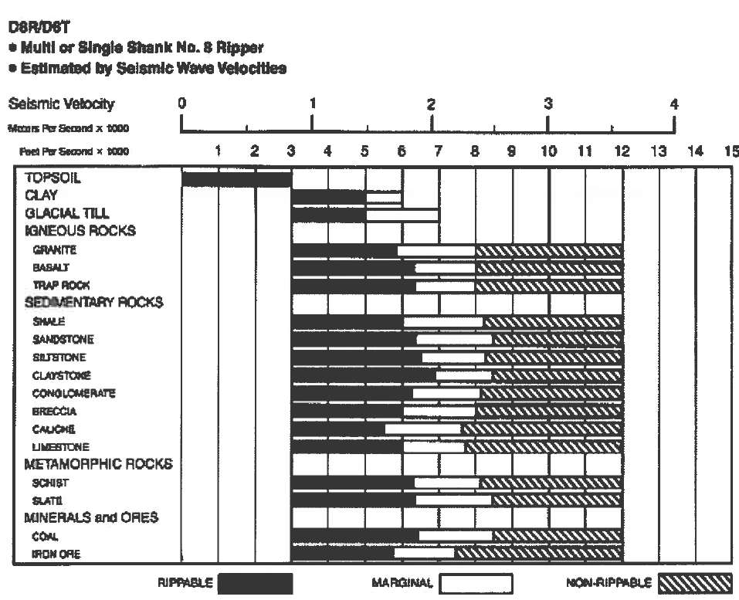  Figure 2.41: opportunities for ripping of soil with dozers  In Figure 2.45 is shown a typical workflow for a loader, whose separate operations, can be divided into extraction, maneuvering and unloading. For a wheel loader this cycle time can be set to 0.5 min. If the earth should be located at the place of unloading 0.2 minutes is added.  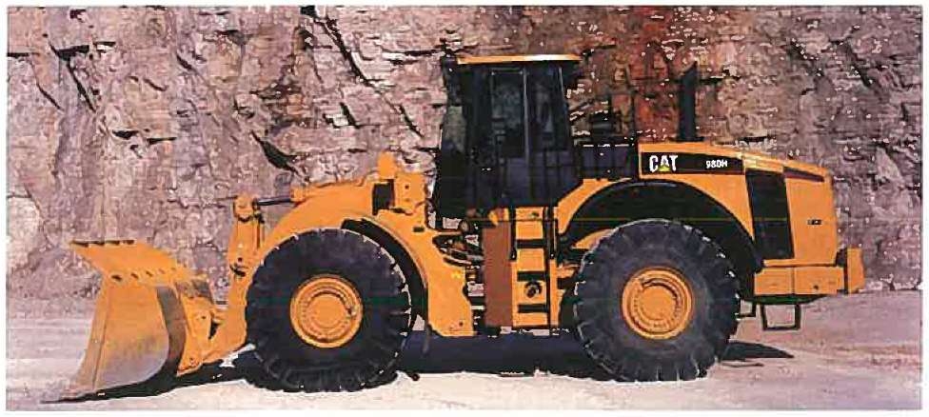  Figure 2.44: loaders.  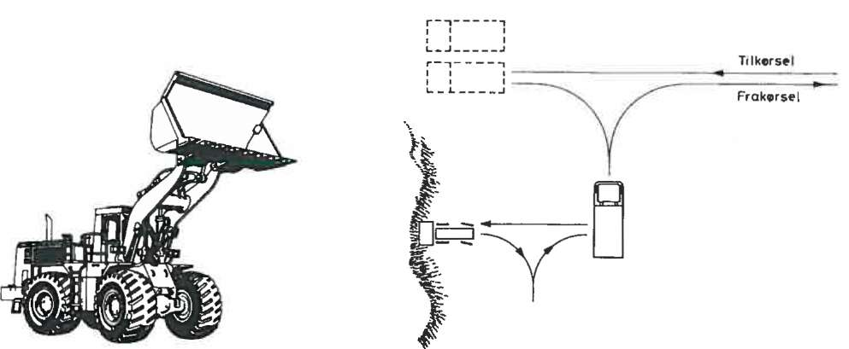  Entrance  Exit  Figure 2.45: The working situation for loaders.  Must the loader, in addition to digging maneuver and empty, also transporting soil at a road distance: L m, a variable orbital time t_{v} is added:  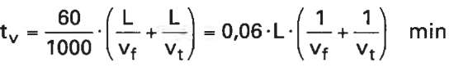 Formula 2.25  where v_{f} is the speed in loaded condition and v_{t} is the speed by empty return journey. For tracked vehicles speed v_{f} is 4 km/h speed and v_{t} to 6 km/h, the corresponding values for wheel machines is 7 km and 12 km/h with a combined roller-and pitch resistance at 15%. Shovel content as mentioned under the hydraulic excavator. Also for loaders one must be aware of the risk of tilting. You should verify that the weight of the soil in the shovel does not exceed 50% of the cargo that can get the machine with rubber wheel to tilt, and corresponding 35% for the crawler. Tilt load for loaders is defined in the 2.14 and 2.15, along with other technical data.  In practice the counter cargo changes with the equipment and counterbalanced weights the machine uses in the current situation. The weight of the soil in the shovel is considered loose. For loading the machines can be fitted with several different types of shovels with or without teeth due to conditions of hard soil or rock.  Some machines can be obtained with 4-in-1 bucket (see fig. 2.55), where the bottom can be opened as a grab, IE. In addition to loading function the grab function are exhausted, and with open shovel dozer function and loading functions as a scraper. In the tables specified dumping heights, IE. the maximum vertical distance from the ground up to the teeth on the shovel in the discharge position. For some of the crawler are given up a smooth transition between speeds.  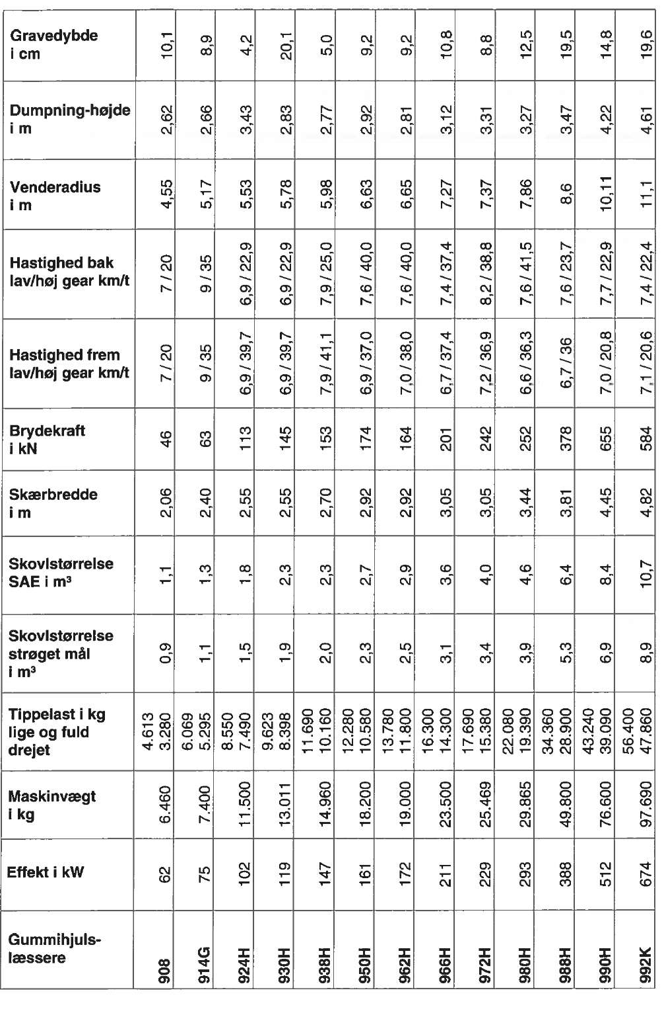  Digging depth in cm  Unload height in meter  Velocity backward low/high gear km/h  Velocity forward low/high gear km/h  Tip load in kg straight and fully turned  Effect in KW  Wheel loader  Machine weight in kg.  Bucket size – stroked measure  Bucket size SAE in m³  Cutting width in meter  Turning radius in meter  Breaking force in KN  Table 2.14:Wheel loaders  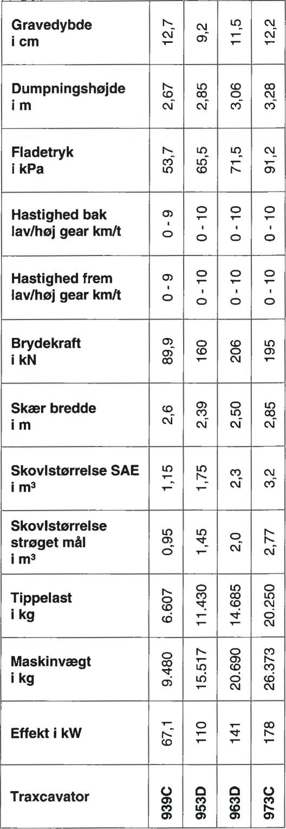  Unload height in meter  Velocity forward low/high gear km/h  Breaking force in KN  Bucket size SAE in m³  Bucket size – stroked measure  Tilt load in kg.  Machine weight in kg.  Effect in KW  Belt loader  Cutting width in meter  Surface pressure in kPa  Velocity backward low/high gear km/h  Digging depth in cm  Table 2.15: Belt loaders  Materials Uniform Moist Mixed Moist clay Rock  Digging minutes 0,05 0,06 0,07 0,30  Maneuvering minutes 0,20 0,20 0,20 0,20  Non-cohesive soil Cohesive soil  Unloading Unloading freely Unloading accurate 0,02 0,06 0,05 0,10  Table 2.16: operation times for belt loaders.  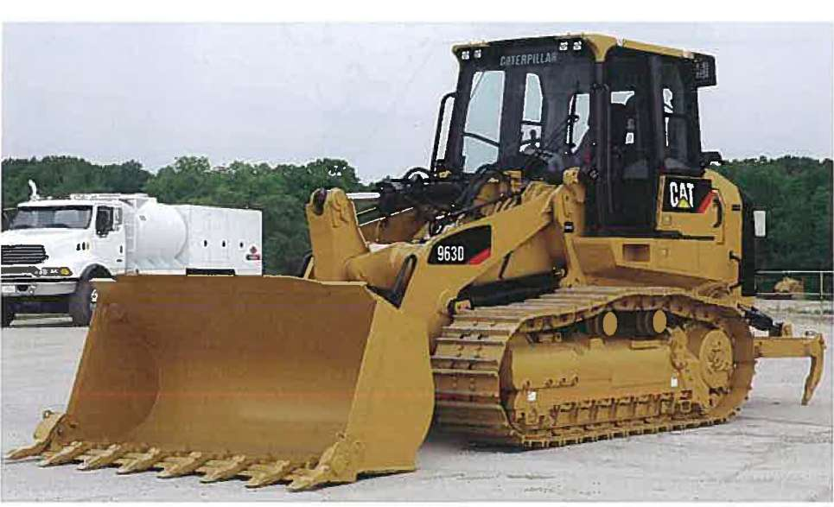  Figure 2.46: Crawler.  Towing shovel machines are one of the old wire pulled excavators which is still in use (fig. 2.47). Towing shovel machines are equipped with belts and have a great reach. But the longer boom the less shovel size can be used, since these machines lifting capacity is limited by the force that causes them to topple.  Towing shovel machine works by first lifting the shovel up under the tip of the beam so that the shovel hangs vertically with digging teeth and opening down wards. Then releases the lifting wire so that the shovel falls  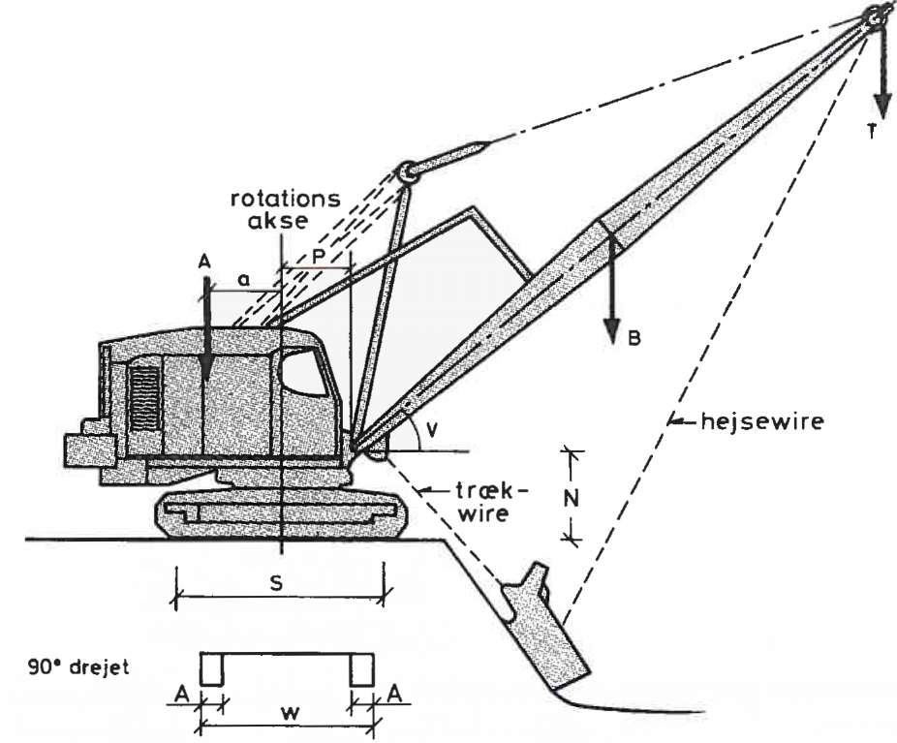  Axis of rotation  Hoist wire  90⁰ pivot  Tow  wire  Figure 2.47: Towing shovel machine.  freely down by gravitational effects so the digging teeth penetrate and dig down into the ground. Then the wire dragged up and shovel is filled by being dragged through the soil. When the shovel is filled it is hoisted and the machine pivots around its center axis till shovel content can be released by slacken the drag wire.  One of the advantages of the large range is that the towel shovel machine can be standing up on the edge of a construction pit and get it all without having to go down to the pit. The same applies to possible transport vehicles that move the soil away from the machine.  In Figure 2.48 is shown a towing shovel machine's theoretical performance in solid measures with the degree of filling for the different soil classes included. In addition there are counted 90 ° pivoting and optimum dig depth. By optimal dig depth means the depth which the excavator provides best. When the depth becomes smaller, the smaller filling. When depth is greater, it then causes the longer drag time. In Figure 2.49 we can learn the optimal dig depths for various bucket sizes, as well as the correction factor f_{os} to multiply with, if there are other digging depths and pivoting angles than provided in the performance curves. The figure h shows the current dig depth, and it should be noted that h_{opt} is an optimum; we cannot just use an average value for h, but must weights according to the digging quantities that are on both sides of the h_{opt}.  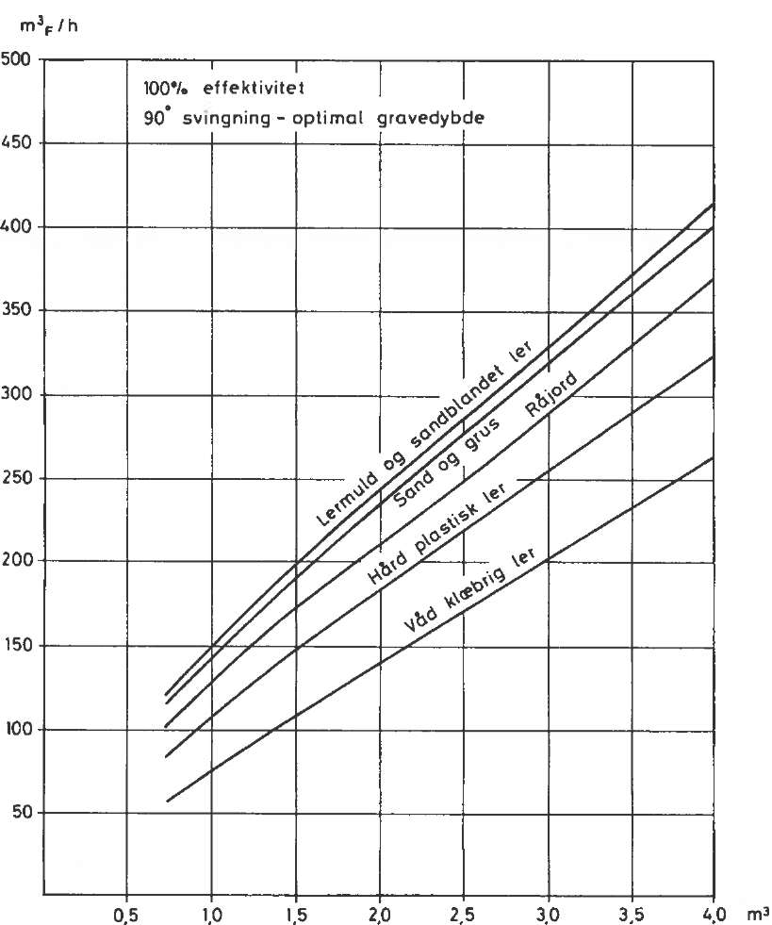  Clay-mould and sand mixed clay  Sand and gravel  Soil  Hard plastic clay  Wet adhesive clay  100% efficiency  90⁰ pivot - optimum digging depth  Figure 2.48: Theoretical performance of towing shovel machines.  It is also possible to dig under water by towing the shovel if the shovel is perforated, but the benefits are naturally reduced very much under these conditions, since the driver partially working in blind and much of the material turns into sludge. One has to calculate with performances here at only 20% of normal.  Towing shovel machines can also be mounted with a grab, and in Figure 2.50, it is specified with a hatched area the volume contents for the two shovel types corresponding to the extracted measures is defined. The grab is primarily used to handle materials such as sand, gravel, crushed stone materials, coal, etc. and to remove materials vertically within narrow sheet piling walls included building pits on shore or capture dams for water. Similarly, the grab is suitable by the handing of materials exactly vertical as in silos. m³  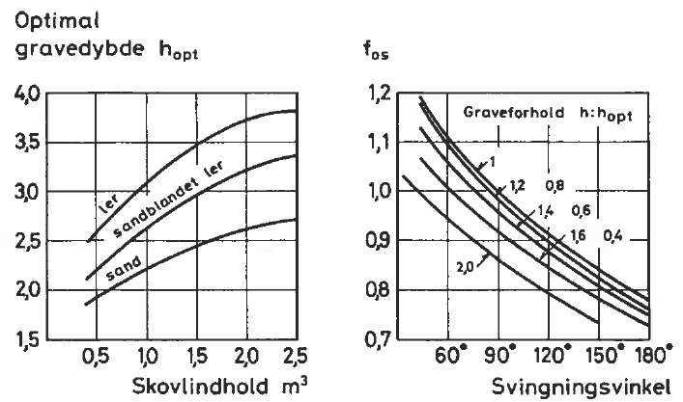  Bucket content m³ Pivot angle  Optimum digging  Depth h_{opt} f_{os}  Figure 2.49: Correction factor f_{os} for digging depth and angle of oscillation.  The performance of machines with the grab can be calculated from the lifting-, slacking and pivot speeds, and with a cycle time of 30 seconds the performance is 80% of the corresponding tow shovels performance.  In table 2.18 specified data for various bucket sizes can be found. Here, the clear height is bucket size (including its suspension system), when it is suspended vertically below the tip of the boom measured from this to the lowest point of the bucket. Height clearance is used together with the beam and its angle of v with horizontal to evaluate the maximum height, we can un-load the soil in.  The boom consists in minimum size of only two pieces; between these can extensions of 3.05 m long uniform middle pieces be applied.  During work it is recommended to keep the booms angle with horizontal angle between 30 ° and 60 °.  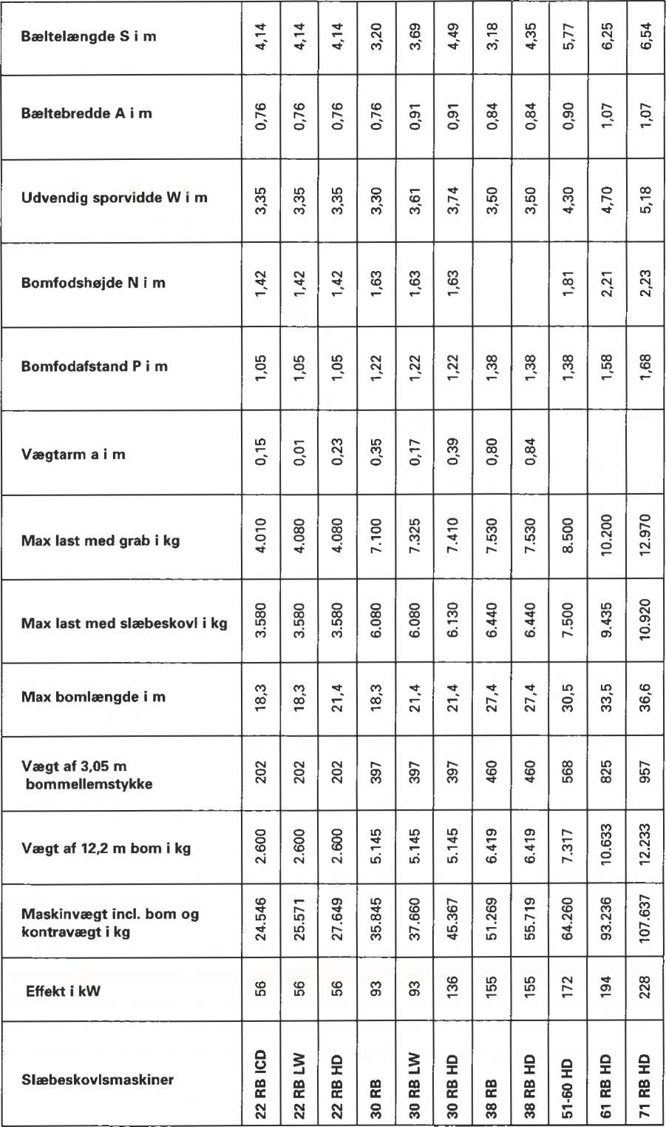  Boom foot distance P in meter  Max load with grab in kg  Max load with tow shovel in kg  Weight arm a in meter  Max boom length in meter  Weight of 3.05 m boom middle piece  Weight of 12.2 m boom in kg  Machine weight incl. Boom and counter weight in kg  Effect in KW  Tow shovel machine  Boom foot height N in meter  Belt width A in meter  Outer wheel gauge  Belt length S in meter  Table 2.17: Tow shovel machine  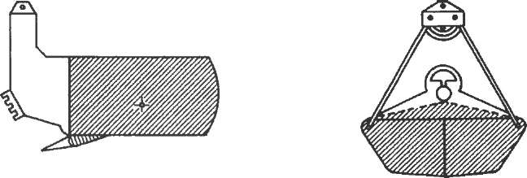  Tow shovel Grab  Figure 2.50: Shovel Content.  Tow shovel  Volume m³ 1,91 1,53 1,34 1,15 0,96 0,76 0,67 0,57 0,48 0,38  Shovel weight kg 2130 192o 1495 1315 1040 950 815 750 610 520  Head room m 5,52 5,46 4,76 4,64 4,42 4,22 4,04 3,86 3,62 3,51  Grab  Volume m³ 2,04 1,61 1,27 1,12 1,02 0,79 0,64 0,51 0,41 0,33  Shovel weight kg 2350 1750 1375 1350 1050 1000 650 625 425 400  Head room m 4,09 3,81 3,50 3,45 3,25 3,17 2,90 2,83 2,56 2,51  Table 2.18: Shovel sizes.  Bucket size is determined by the maximum permissible T, as the machine must bear. It is either the maximum load, as declared by the supplier what wires, cords, retracting rollers etc. can handle or tilt-load as the weight that precisely can cause tilting of the machine around one of the belts. With the use of terms from Figure 2.47 and with boom length 1, you get by taking the torque on larval bands edge the tilt-load T  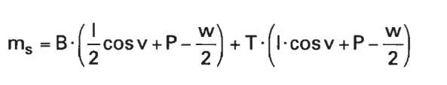Formula 2.26  Left side m_{s} is the stabilizing torque of A (a + w/2) from the machine's weight and the mounted counterweight at the rear of the machine, but without the weight of the boom which depends on the angle with the horizontal is more or less contributing to tilting of the machine. From the formulas and the technical machine data in table 2.17 you can calculate T for a given working situation. This calculated tipping load should be reduced according to the local standards for safety. In the United States are considered e.g. 75% utilization by towing bucket work and 68% by the use of grab. The corresponding figures for the United Kingdom are 66.33% and 53%.  There can now be chosen a shovel size, so that its weight with soil both is less than the calculated reduced load and in schema specified maximum. The weight of the soil can be estimated from the in table 2.18 specified shovel volume multiplied by the soil's density in the fixed measures.  All the above calculations are based on horizontal, sustainable grounds and without wind forces. In case of work eg on sloping terrain, account must be taken of this by calculating the tilt load.  In addition to towing shovel machine, there is wire-mounted backhoe towed machinery. They are very rare in Denmark, where they gradually are replaced by the hydraulic excavators. For wire-mounted backhoes, one can multiply the towed shovel machines data by 1.25.  All excavators are now almost all hydraulic driven. They are faster, stronger and more accurate than wire towed machinery, but on the other hand, may not be as robust and usable for so many purposes like as towing shovel machine. It can e.g. be fitted with hook instead of shovel for use as mobile crane or with device for driving of piles.  The hydraulic excavators are available both with belts and rubber wheels, as well as with mounted backhoe. In Figure 2.51 is shown a hydraulic belt driven excavator  The machine is constructed of an undercarriage, of cart, boom and shovel.  Digging boom consists usually of a lower, middle and upper piece, which each are fitted with hydraulic cylinders to control their movements. Often sold machines with mono-booms ie to under-and middle piece in one piece. One cannot make the length of the boom shorter to allow greater break-force; it is desirable, if fx must dig in rocks. The machines can be delivered with different lengths of the various pieces, as shown in the figure, with consequent different digging patterns - as for towing shovel machines allows a longer arm a small shovel.  In the figure are shown examples of what the excavator may bear in addition to the bucket by various seizes, both in the belts direction and across the perpendicular to the belts. The numbers in the table marked with * are expressions of what the hydraulic cylinders can last to in the different positions; the other numbers indicate tip-load with 25% safety.  By digging, where all positions can occur, we should calculate with the values stated in the max column. On the back of the shovels are usually welded a hook for wire suspension e.g. for use for lowering of the sewage pipes by a sewage work, and here's the table's other numbers be of use.  Changing of shovel can be done in a few minutes if the excavator is delivered with interior design for a mechanical quick shift. In Figure 2.52 are shown different bucket types. Choice of shovel size can be from three different criteria: breaking power, maximum shovel content and rendering width.  Break force is greater than of many other machines, since it is established partly as a radial force through the hydraulic cylinder that controls over the arm, and partly as a losing force produced by the cylinder boom, which tilts the shovel on its pivot. Maximum breaking force for a particular machine one get when the angle between the upper arm and its cylinder is 90⁰ and choosing smallest and lowest shovel height as possible.  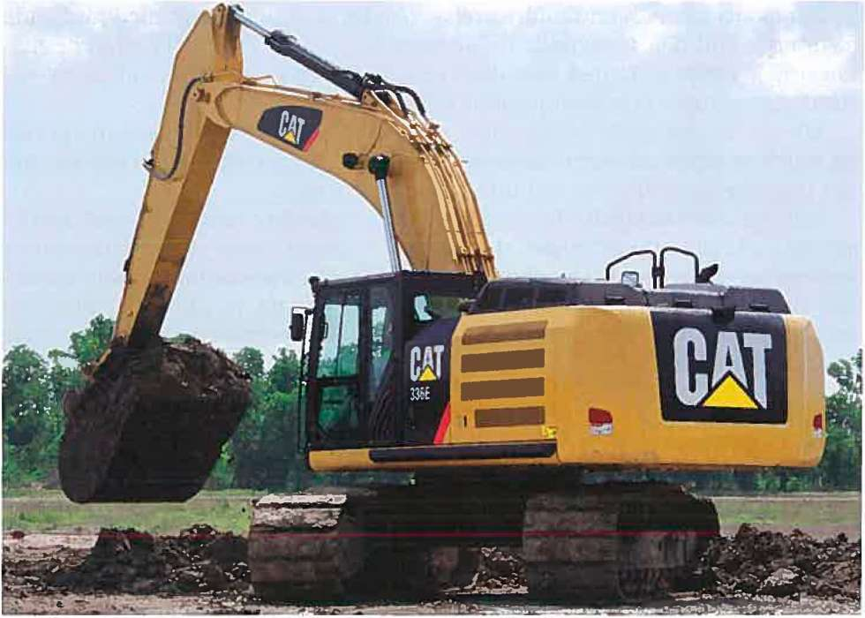  Figure 2.51: Hydraulic Excavator.  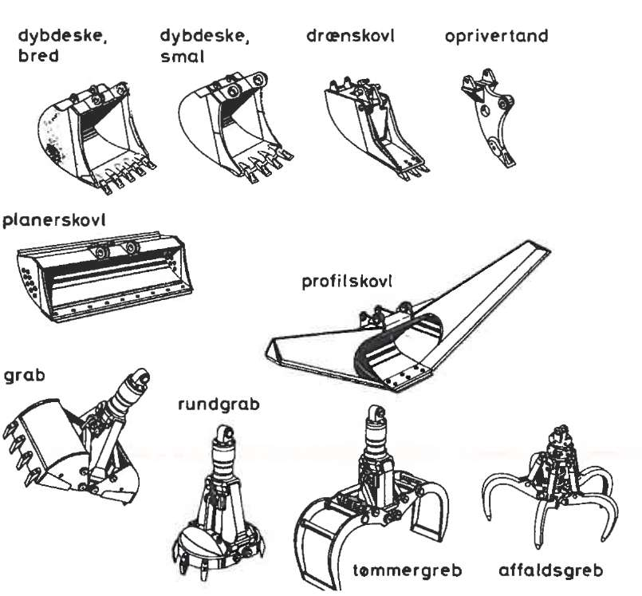  Leveling shovel  Profile shovel  Round grab  Grab  Lumber clamp  Scrap fork  Backhoe, wide Backhoe, narrow Drain shovel Ripping tooth  Figure 2.52: Shovel types.  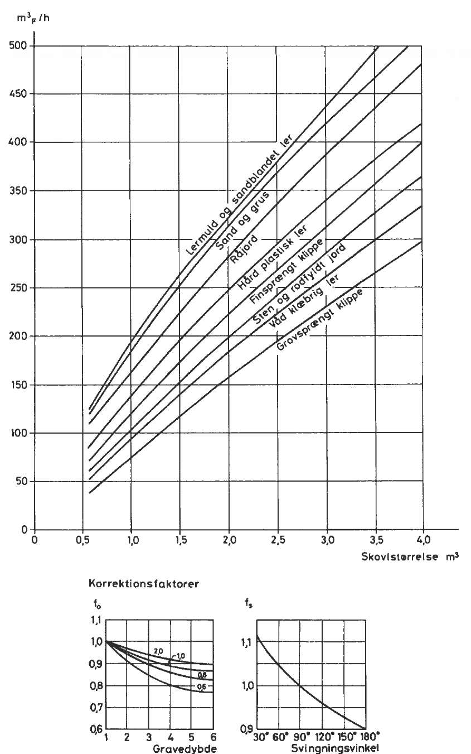  Clay-mould and sand mixed clay  Sand and gravel  Soil  Hard plastic clay  Fine graded blown rock  Stone and rocky soil  Wet adhesive clay  Coarse blown rock  Digging depth Pivot angle  Corrections factors  Shovel size  Figure 2.53: Theoretical performance of hydraulic excavator for various soil types.  A narrow shovel provides more force per length unit of the cut and a low bucket also gives less torque arm from the shovels suspension point to the teeth. Since the cylinder power torque is given, one gets thereby a larger losing power  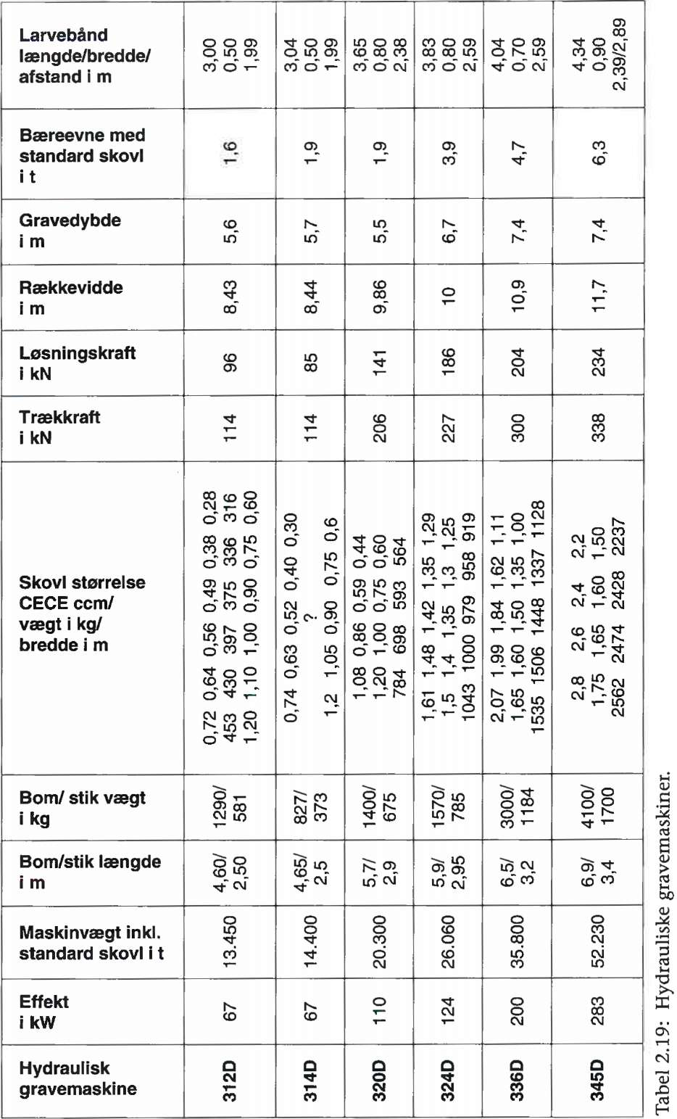  Shovel size CECE ccm/weight in kg  Width in meter  Boom weight in kg  Boom length in meter  Machine weight incl. standard shovel in t  Effect in KW  Hydraulic digger  Pulling force in kN  Losing force in kN  Range in meter  Digging depth in meter  Carry capacity with standard bucket in tonnes  Caterpillar  Length/width/distance in meter  Table 2.19: Hydraulic Excavator.  Shovel size is read - besides in the stroke measures - often in brochures at their SAE measuring which is the volume contents with heaped measure taken out from a rake slope of the ground at 45⁰, or after CECE standards which are counting on soil slope is at 27 °.  Skilled machine operators can fill up the shovel - when it comes to light moistened clay soil - 10% more than the SAE measure. Sand and gravel correspond to this objective, where harsh dry clay soil more is according to CECE standard. Blown rock meets barely the stroked measure. From soil type shovel weights and machine's carrying capacity, we can select maximum shovel size. The specified bucket weights are for ordinary so-called easy buckets.  To work in hard soils and with rock materials, one is using little heavier and more powerful shovels. Teeth should be replaced in due time because otherwise performance can fall by up to 20%. On the teeth can one attach a plate if digging sand or other cohesion lose materials, in order to increase shovel volume  Figure 2.49 topside shows the hydraulic excavator engine's theoretical capacity in m3f/hour as a function of the shovel size and soil types. It is anticipated that the excavator is equipped with backhoe. Height digger’s capacity is about 10% higher. The theoretical capacity assumes that the real dig depth for the bucket size is optimal and digging machinery must pivot 90⁰ between the loadings and unloading of shovel. If this is not the case, there must be corrected through two factors: f_{o} determined from the dig depth and the bucket size, and f_{s} which is determined from the pivot angle of. f_{o} and f_{s} is derived from the two bottom graphs in Figure 2.49.  By working with pipelines it can is often worthwhile not to make ditch wider than necessary. If one dug too much away the amount of backfilling gravel is increased in order to fill the trench again. Therefore is narrow shovels selected when excavating trenches, regardless of less volume of content. In Figure 2.49 is shown the hydraulic excavator engine's theoretical performance with backhoe. Here specifies the curves for the f_{o} the various bucket sizes.  Leveling buckets, which is shown in Figure 2.52 is a kind of dozer blade for an excavator. It is used for leveling work and because it is fitted with a tilt device it can also do tilted. The leveling bucket is also used as a digging tool and the width of 2 m is max for loading of trucks, which has only 2.4 m wide beds. Finally, the leveling shovel used in perforated design is capable of cleaning up of ditches.  In addition to the listed shovel types as extra equipment for a hydraulic excavator can you get crane hook, magnetic plate, vibration plate and hydraulic hammer to the demolishing of materials, ripper tooth, scrap cutter and drilling equipment.  In table 2.19 is specified technical data of hydraulic excavators of caterpillar type. Range and digging depths is maximum. The specified carrier abilities are either what can be lifted, or what a standard shovel can carry in at the largest range.  Hydraulic excavators on rubber wheels is preferred often by trench works in cities for not to cause damage to the asphalt. Another advantage is the high cruising speed. In Denmark no bigger machines than working-weight of 20 tonnes is used. By greater weight the pressure from support feet’s are larger than the underlay permits.  Support feet are necessary partly to stabilize against tilting and partly in order to provide a steady working process without rocking movements. Machines on rubber wheels are approximately 10% more expensive than equivalent excavators to buy.  There are larger excavators than those specified in the table. Shovels of up to 10 m³ are used on very large earthworks where transport vehicles determine the economic limitation for the size of the machines. Excavators with bucket up to 30 m³ are operating in opening coal mines and similar sites. The large excavators are all fitted with a reversed-mounted backhoe, where the bucket bottom facing downward as on a loader.  The motor grader, also known as road grader, is designed to finish working on a soil surface, so this can be delivered in the correct elevation and plan, i.e. without waves or marks from digging equipment.  It is important with this accuracy, in particular due to material consumption of the overlying construction materials in roads and squares. Other uses for the grader are the laying and fine control of fillings as well as trench digging and slope regulations.  The latter function is due to a highly movable blade which can be rotated about a vertical axis, can be displaced off to the side and tilted right up to its vertical position. Furthermore the front suspension is allowing the wheels to tilt to the sides in order to resist lateral loads – and the front axle can also pivot so that the wheels are in each own plane.  The performance data are stated in table 2.20  Diesel and Lubrication:  Propellants (Diesel) is added:  0.16 l / kWh for light work  0.20 l / kWhfor normally work  0.24 l / kWhfor hard work  Cost of lubricants for smaller machines 10-12% of fuel consumption  and 30% for large hydraulic machinery.

